Python – document-ppt

<https://docs.google.com/presentation/d/1hQhikd_GaH6zxPcZ_SvzWe7ucBYAak6z/edit?usp=sharing&ouid=100134677879427327705&rtpof=true&sd=true>

Python – online document

[Hello World Program in Python (How to Print Hello World?) (tutorialsfreak.com)](https://www.tutorialsfreak.com/python-tutorial/examples/hello-world-program-in-python)

**https://www.tutorialsfreak.com/python-tutorial/**

**Python Concept**

Python is a interpreted(write the line by code and execute), object-oriented(structural way to maintain code) and high level programming language(where we have lot more library which work automatically) 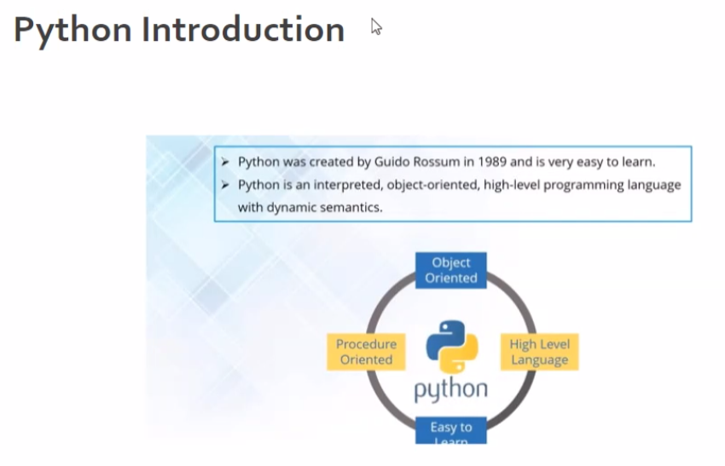

Python operators.  
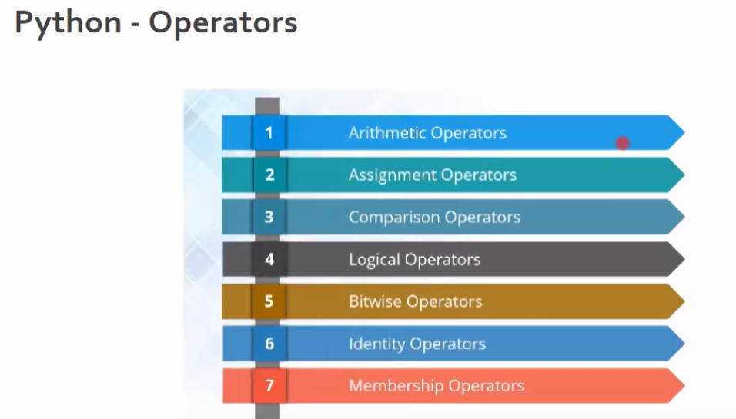

**Arithimetic operation :** + - / * **Assign operators :**

Floor decimal – where all

10//3 > 3 --- where all the number after . will get vanish

Modular division

10%3 > 1----it will show the reminder

**Comparison operators** ---- it shows true or less ( < , > , = etc)

**Logical operators** ---- when we want to compare more than one condition by using **AND OR** condition.

**Bitwise operators** ------ will use **&** for and **|** for or

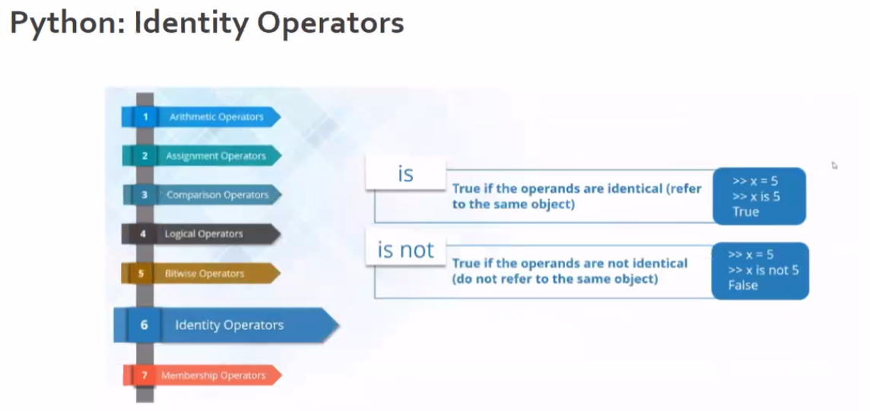

**Membership operators** ------ **in** and **not in**

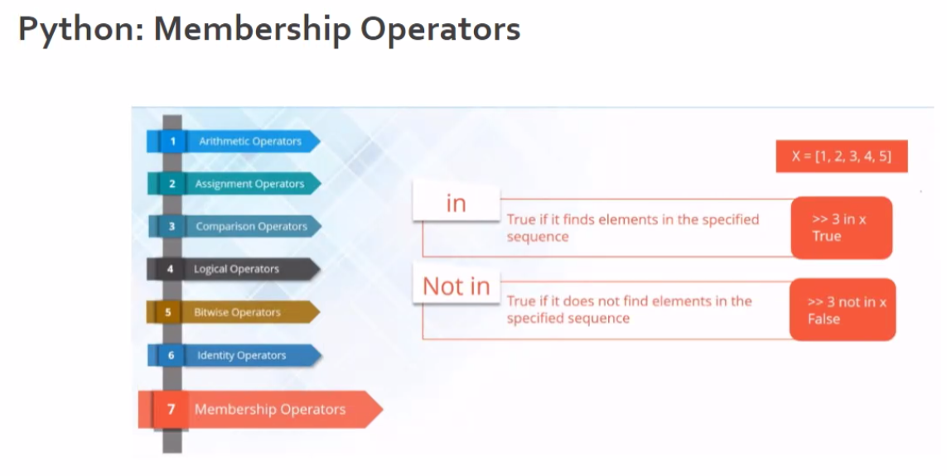

Msg = “good morning friends”

“morning” **in** msg 🡪 true

Python data type

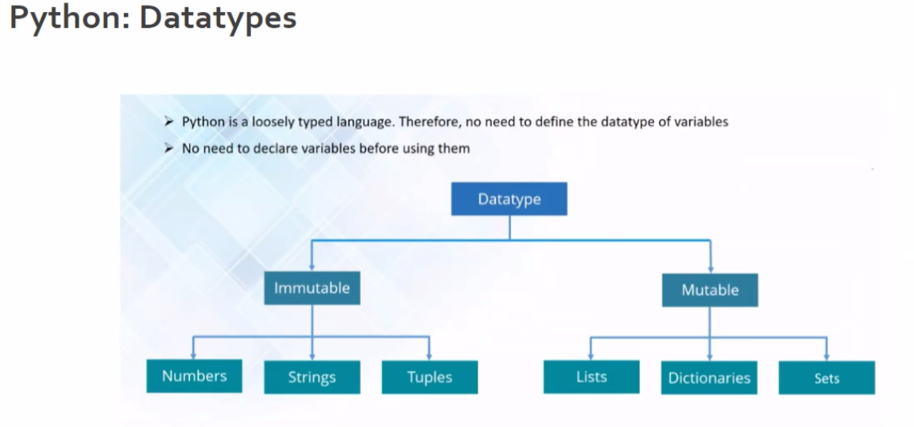 if we can change position its mutable

Which we cant change is immutable

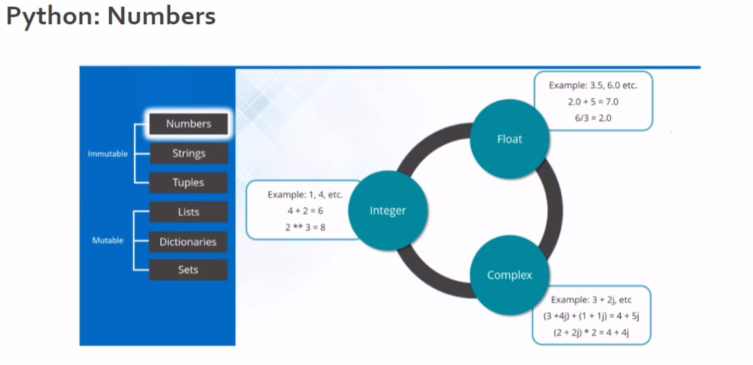

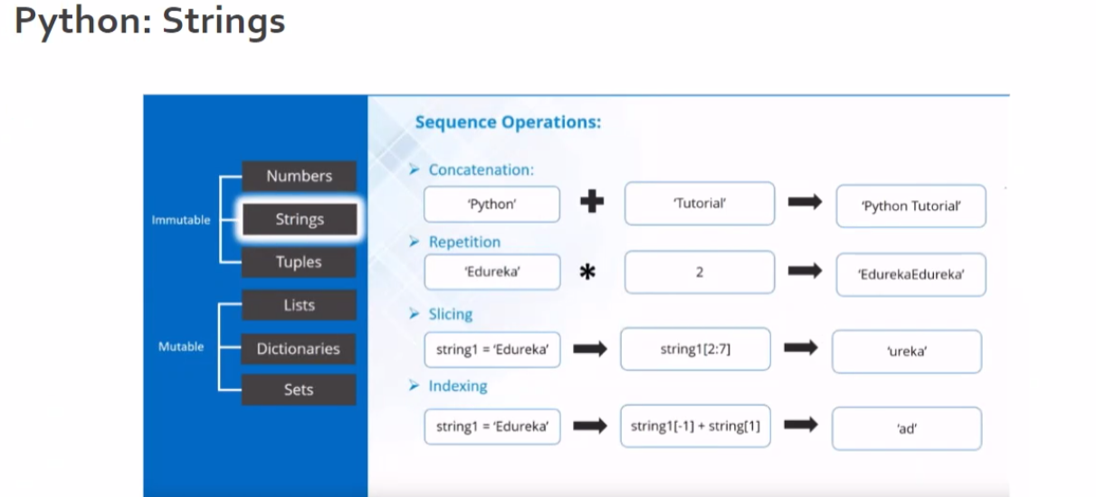

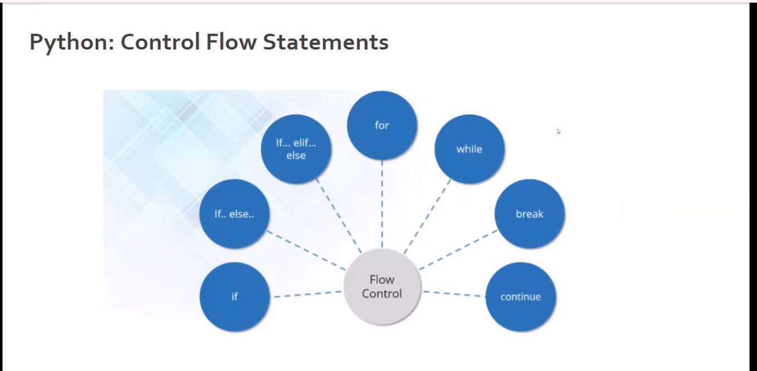

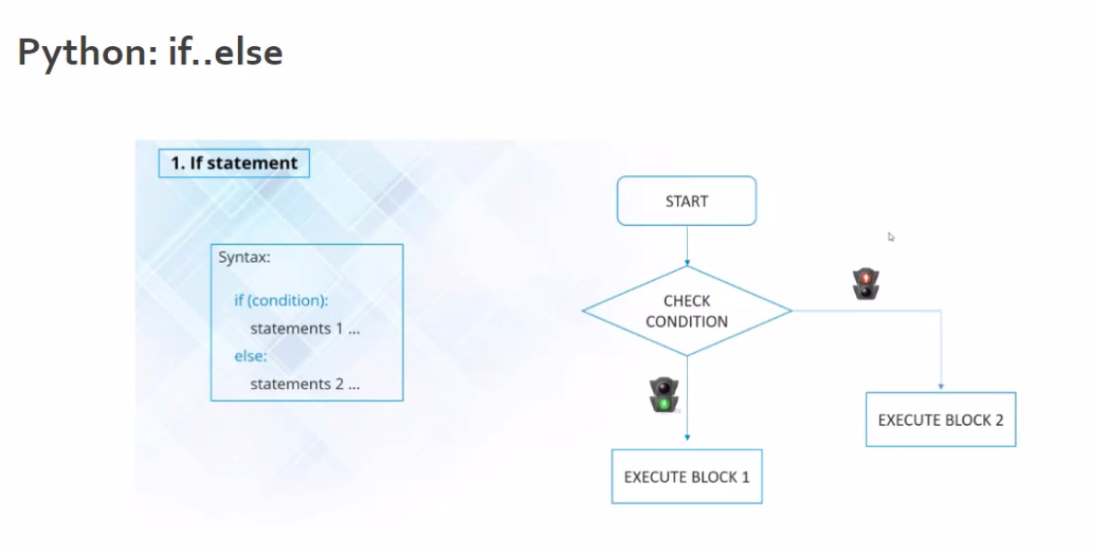

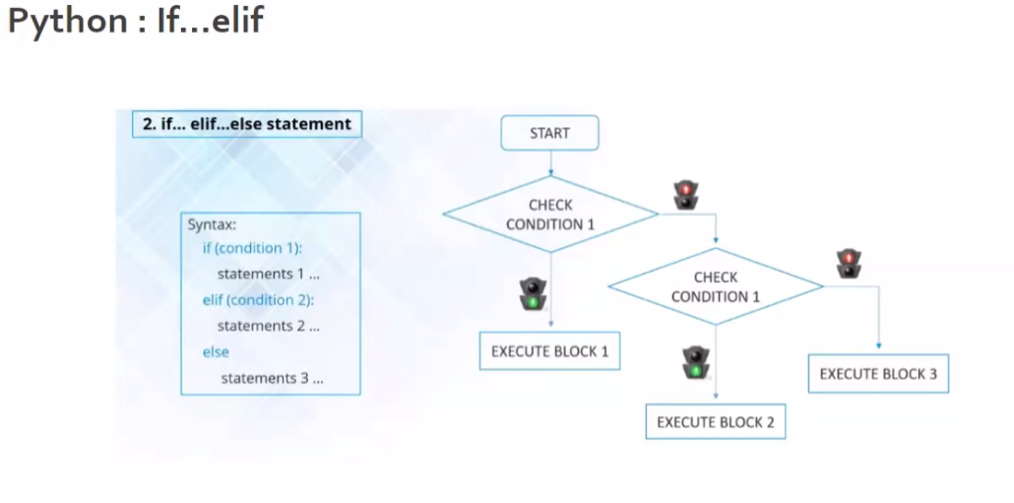

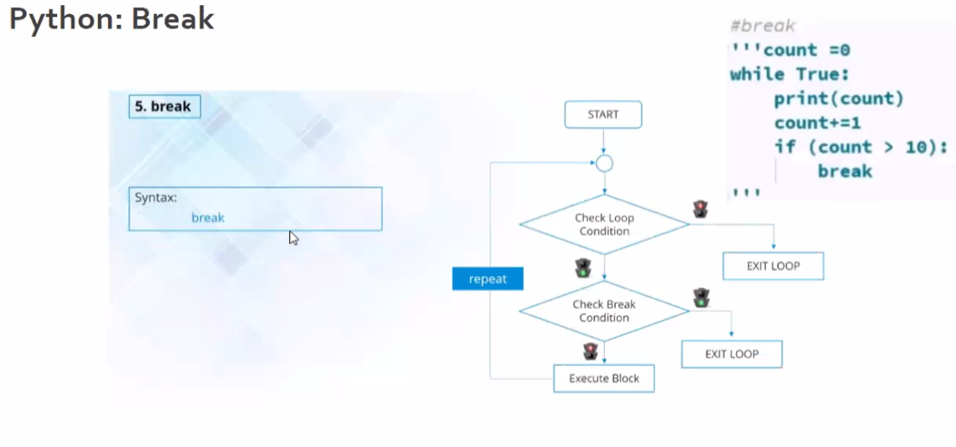

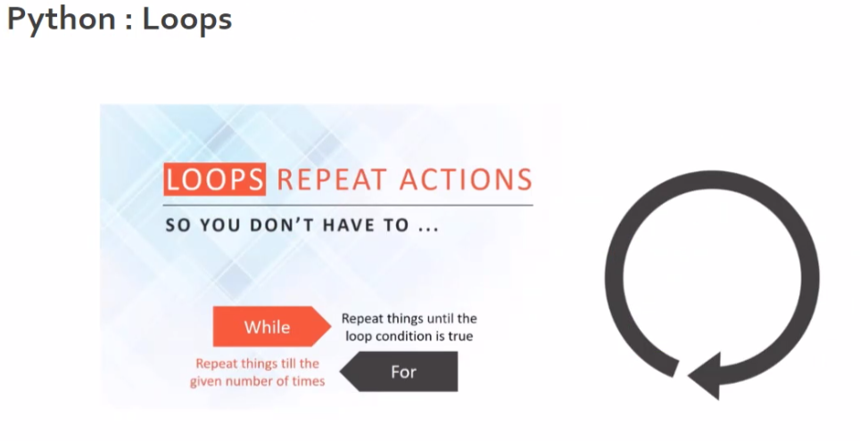

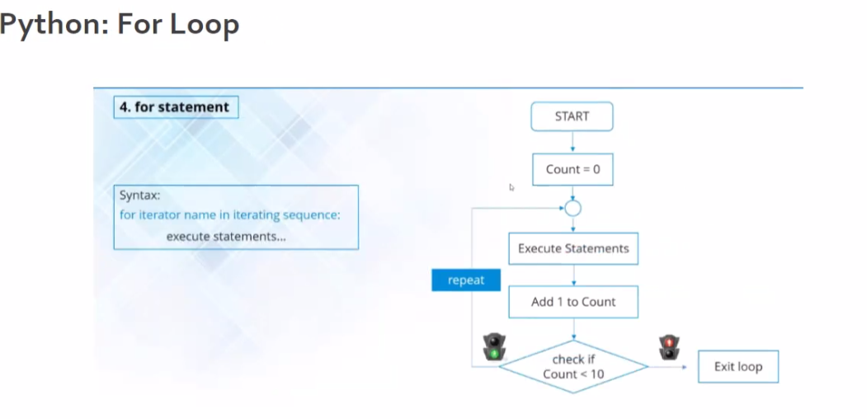

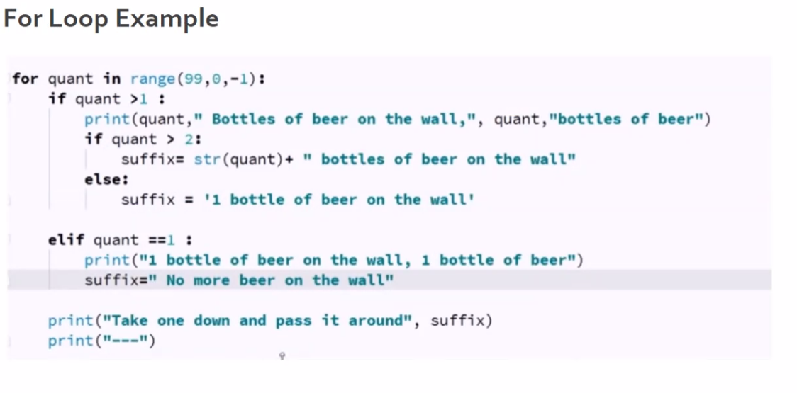

LEAP YEAR EXAMPLE CODE.

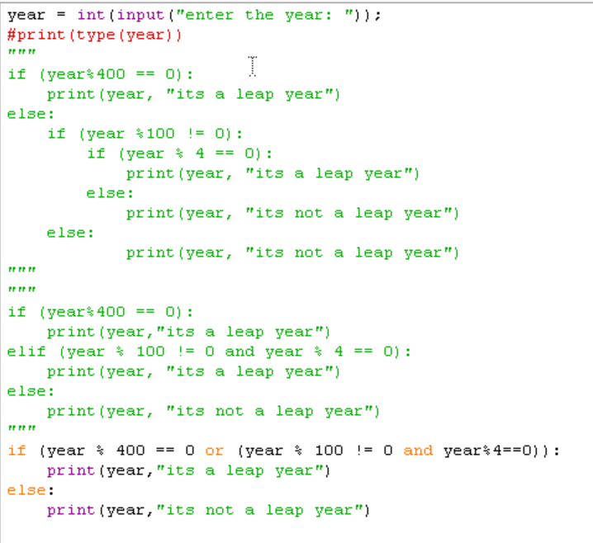

Example 2 : write a interest by using MATH module

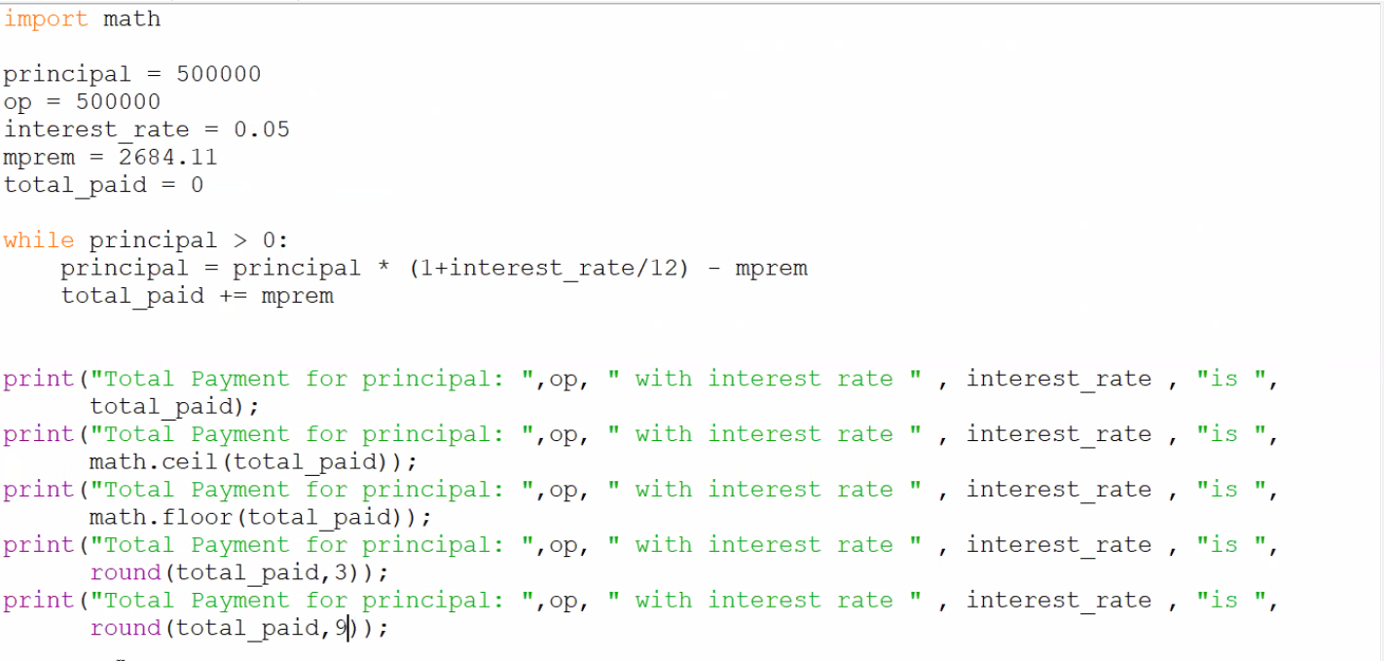

Example 3 : question  
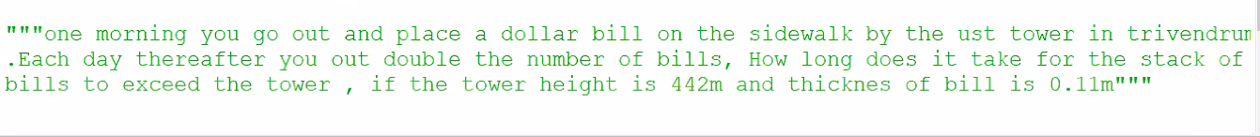

Solution:

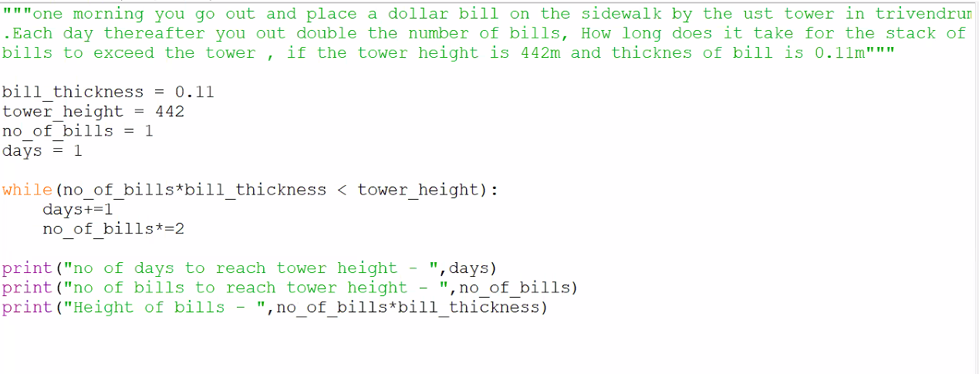

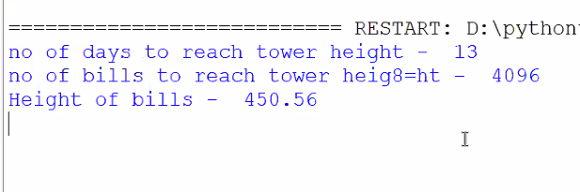

**String**

Message = “learning python for data engineer”

Notification = ‘Saturdays are not working days’

Print(message, “any message”,notification)

**#escapes code=**

\n = new line

\r = carriage return

\t = tab

\’ = literal single quote ( message = ‘good morning friend\’s’) \will escape the ‘

\” = literal double quote

\\ = literal backslash

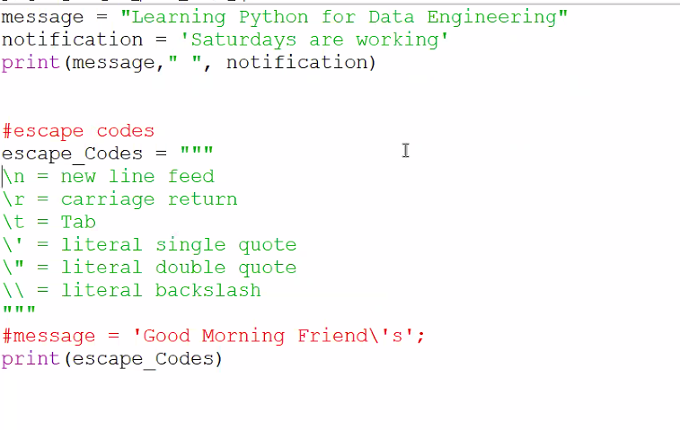

**String indexing:**

Message = “learning python for data engineer”

Print(“the 6th position is” message[6]) 🡪i

**Slicing:**

Diving the words from and to

Print(“the string from 9th position to”,message[9:] 🡪 python for data engineer

Print(“the string till 9th position to”,message[:9] 🡪 learning

Print(“the string from 9th position to 15th position”,message[9:15] 🡪 python

Print(“the string last 5th position ”,message[-5] 🡪 i

Print(“the string from last 5th position ”,message[-5:] 🡪 ineer

5th to -3 position[5:-3]

Till -3 position [:-3]

Print(len(message) 🡪 display the length of the string

Print(message[::-1]) 🡪 diplsya in reverse format

Print(message.count(“in”) 🡪 diplsy the count of IN

Print(message.upper()) 🡪convert to uppercase

Prin t(message.lower()) 🡪convert to lowercase

Print(message.index(“a”)) 🡪 display the index position

Print(message.find(“in”) 🡪display the position

Print(message.find(“in”,9) 🡪display the position which is after the 9th position

Print(message.find(“in”,29,35) 🡪display the position which is between 29 to 35 position

Print(message.split()) 🡪 split the string into list

Print(message.split(“in”) 🡪 except in other word will get splitted

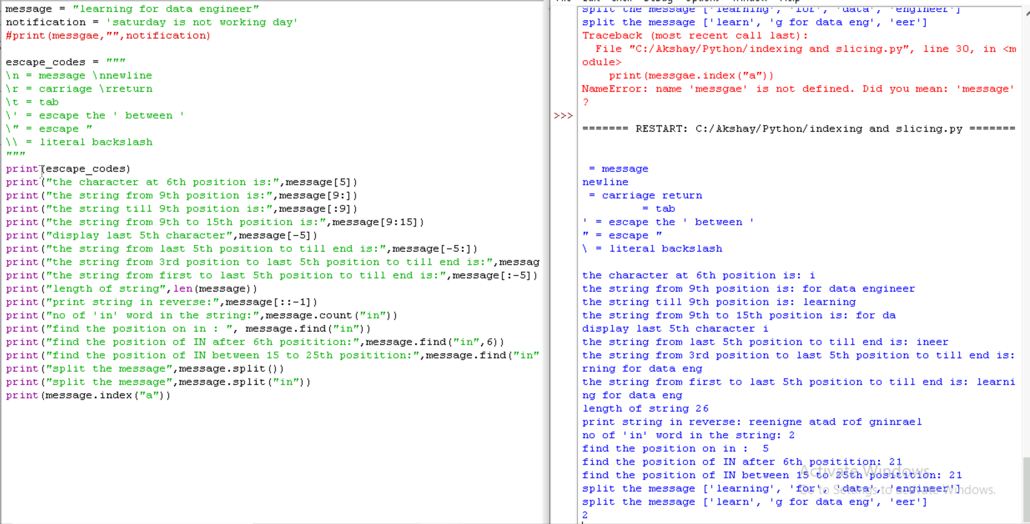

Assignments:

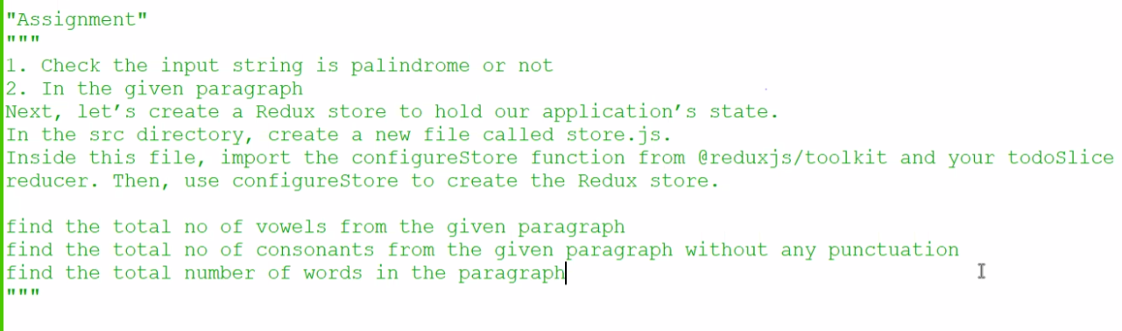

Solution:

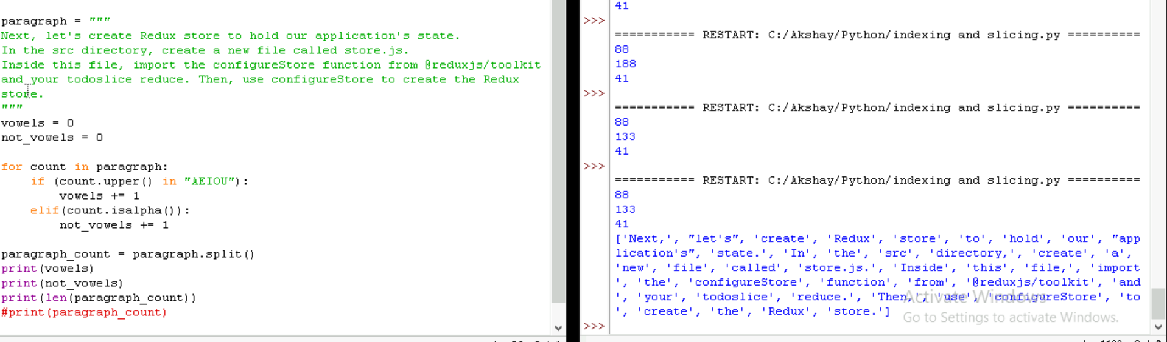

**Data type - TUPLE**

It’s a data type where we can give multiple value. IMmutable data type

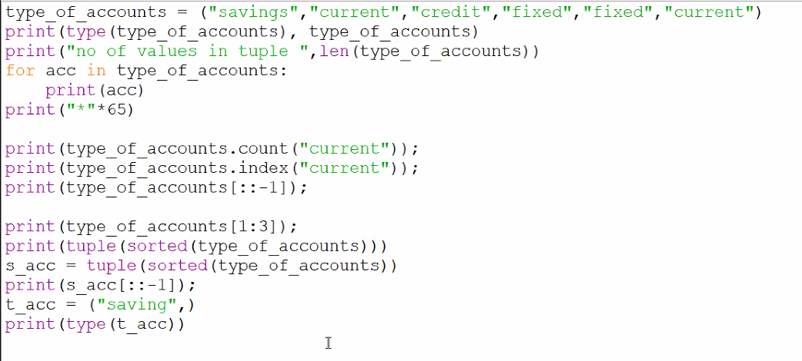

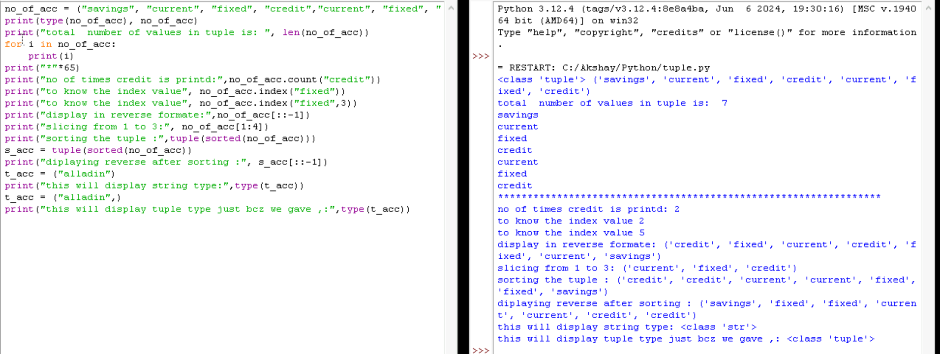

Tuple don’t have append attribute.(variable.append = “aksjay”)

Cant modify the existing (valiable[4] = “akshay”)

**LISTS**

It’s a data type LIS1 = [“Akshay”,1,1.0] specified between [ ] and it’s a mutable data type.

-append (list1.append([“Akshay”,”bharath”]) 🡪this will create list inside the list

-insert (list1.insert(3,“Akshay”) 🡪insert at the 3rd index

-append (list1.append(“akshay”)🡪append at the end

-extend (list1.extend([“alladin”,”Sudhir”]) 🡪extend list with the given variable

-print(len(list1)) 🡪display the length of list1

-print(list1[3]) 🡪we can use index and get the values [3],[-1][2:5],

-pop (list1.pop()) 🡪delete the last value

Remove (list1.remove(“Akshay”) 🡪 Akshay will be removed

Two dimensional arrey:

List1 = [1,2,3]

List2 = [4,5,6]

Full_list = [list1,list2] 🡪 ([1,2,3],[4,5,6])

We can find single variable using index value [0] [0] 🡪1

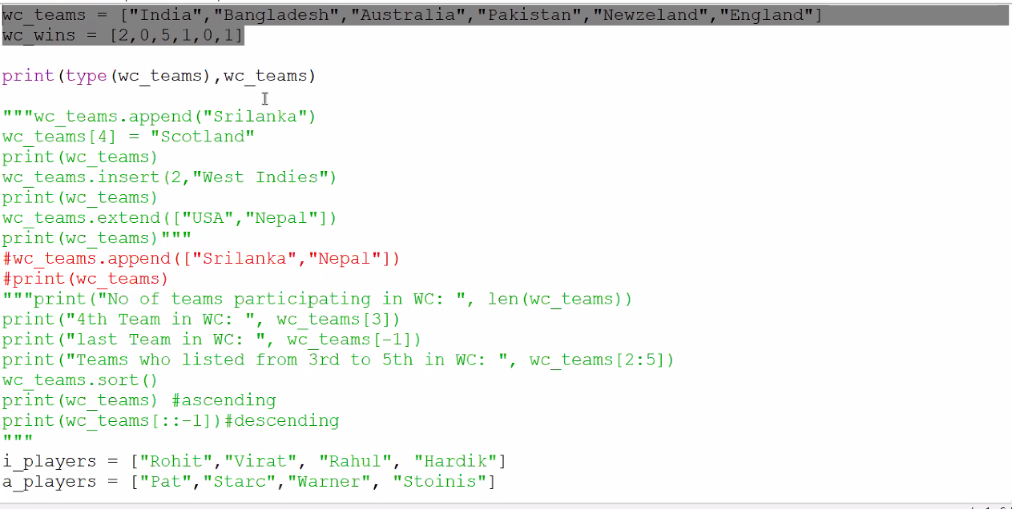

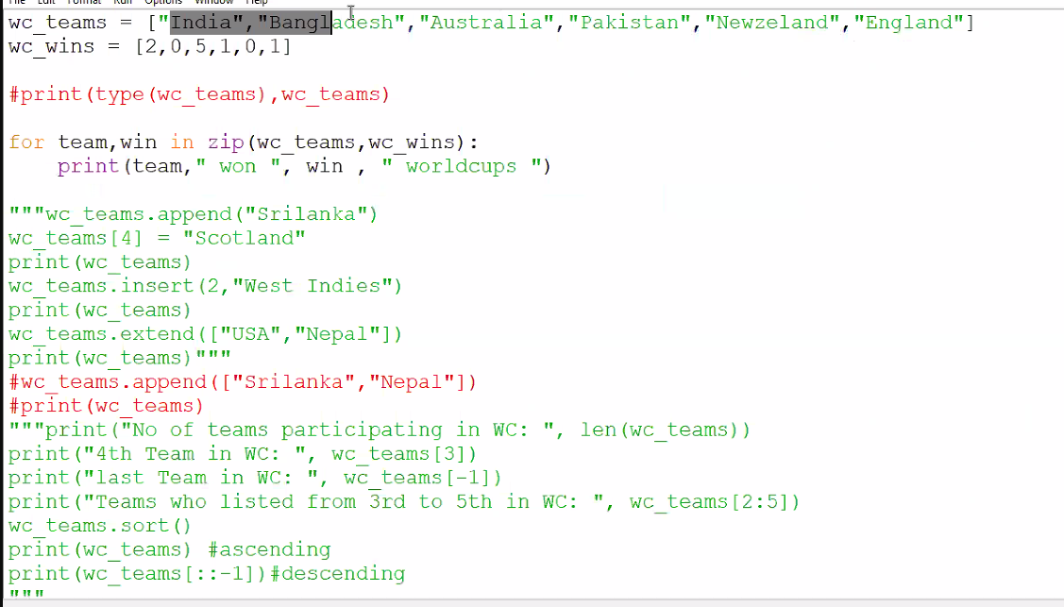

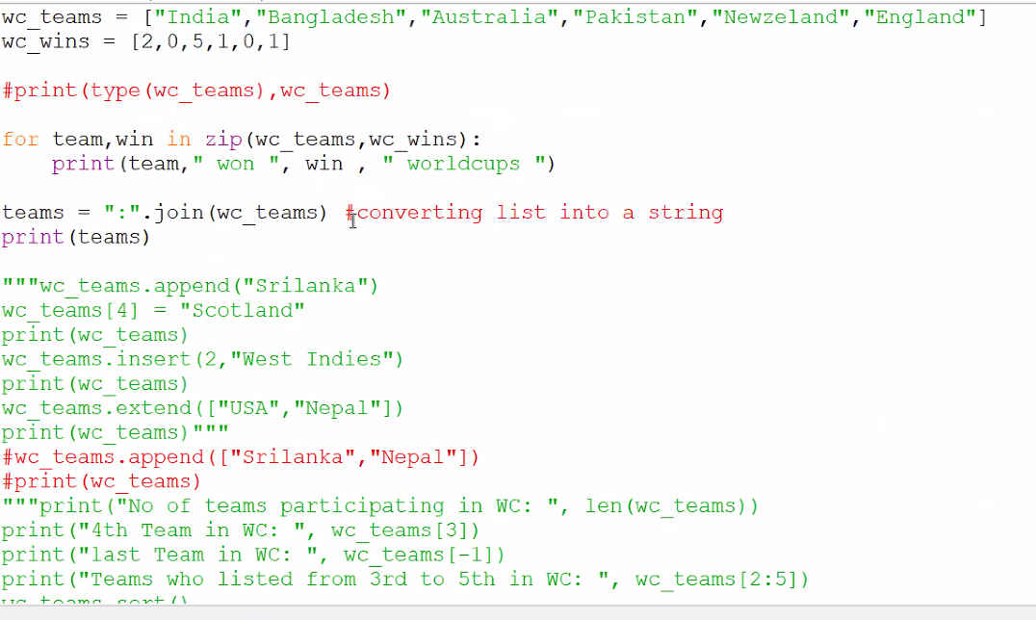

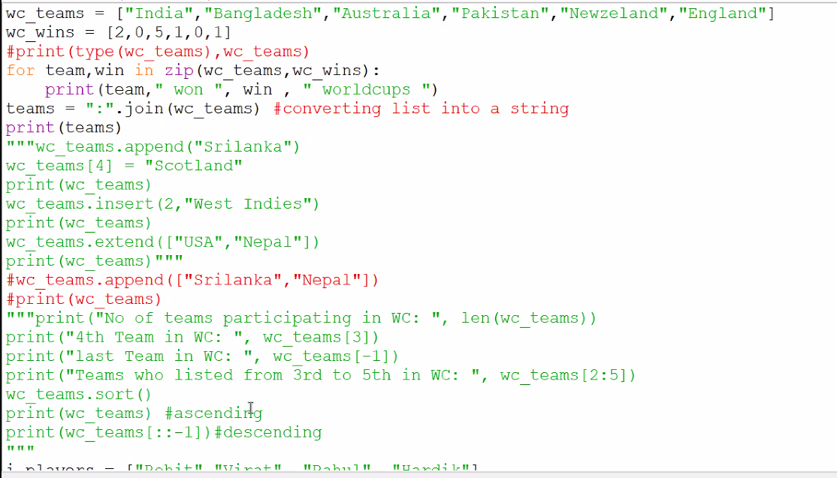

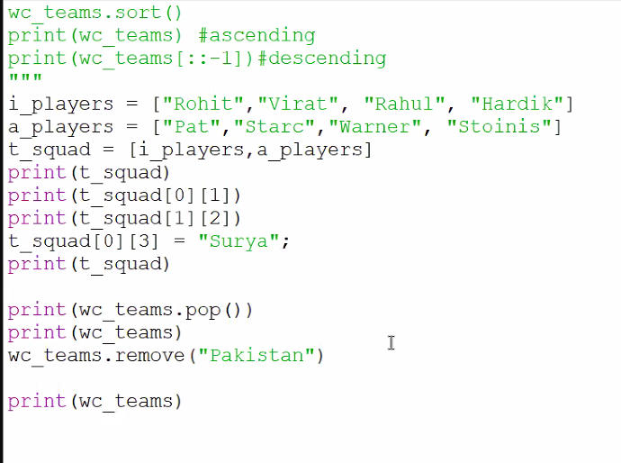

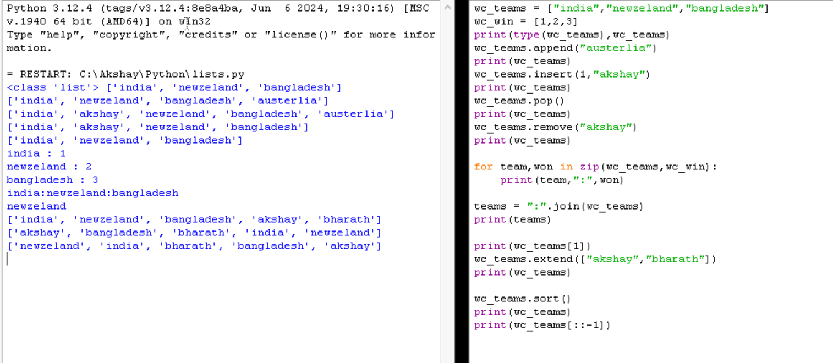

**Dictionary**

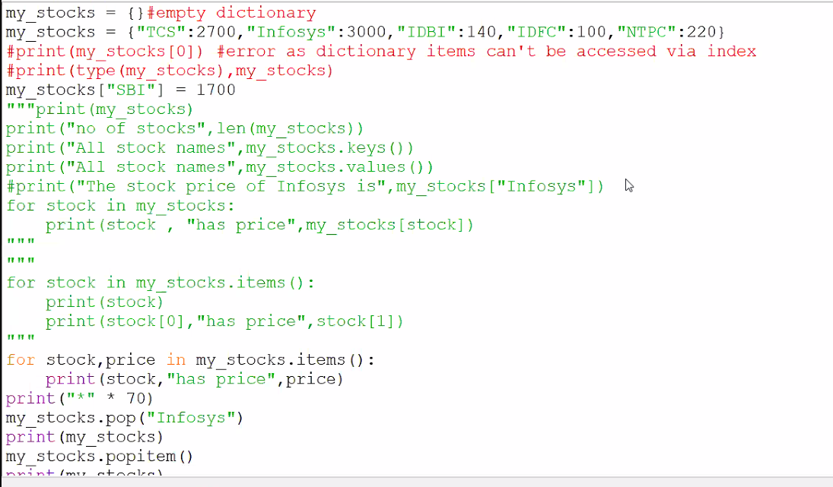

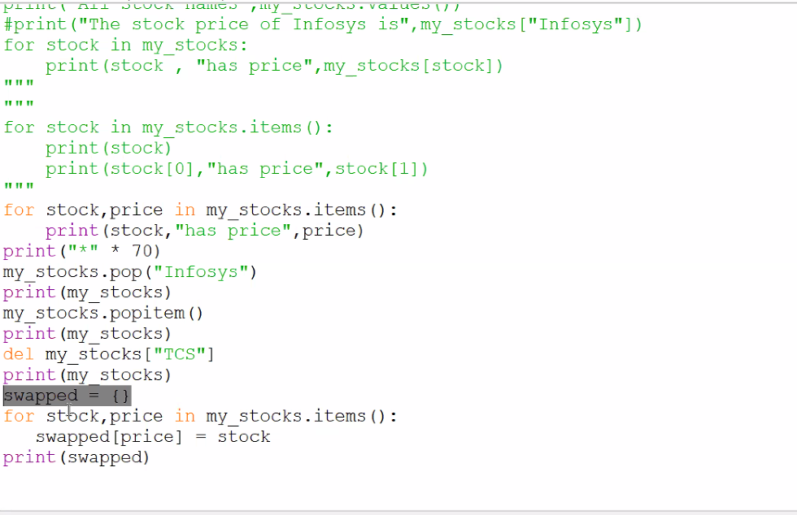

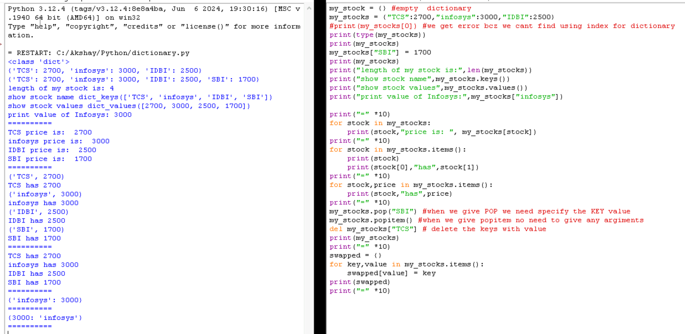

**SETS**

by using sets we can get the unique value it wont allow dublicate

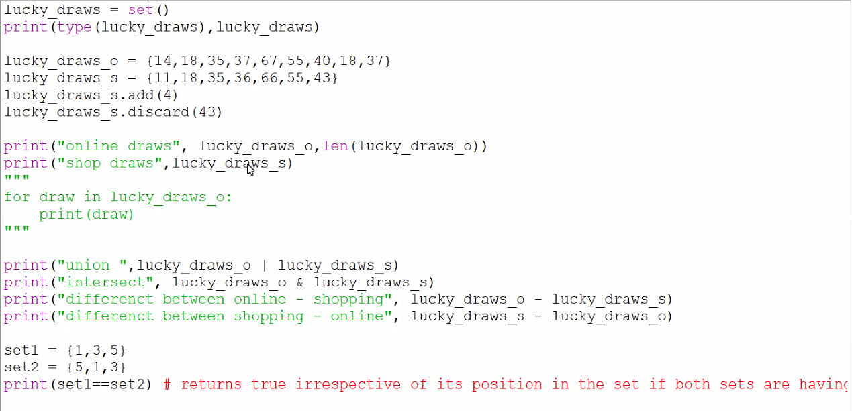

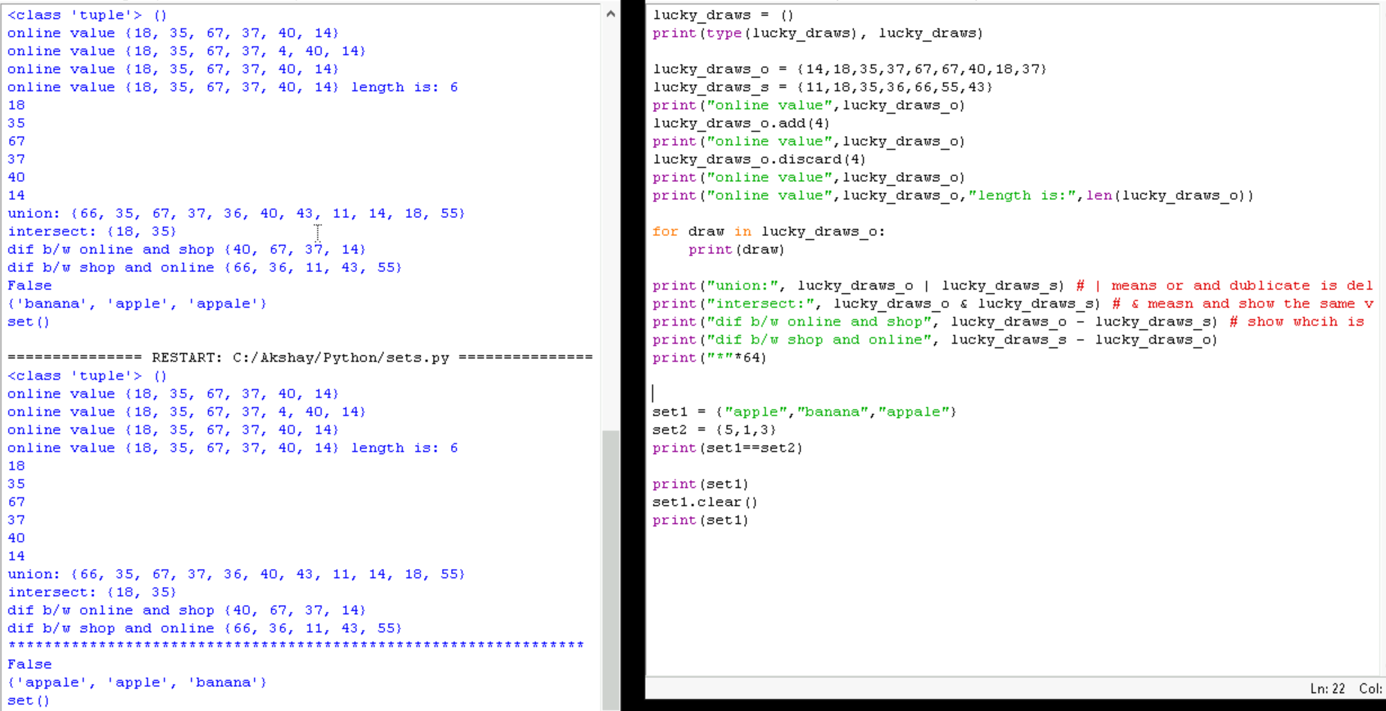

**Creating functions**

Function is used to reusability of the function when ever needed.

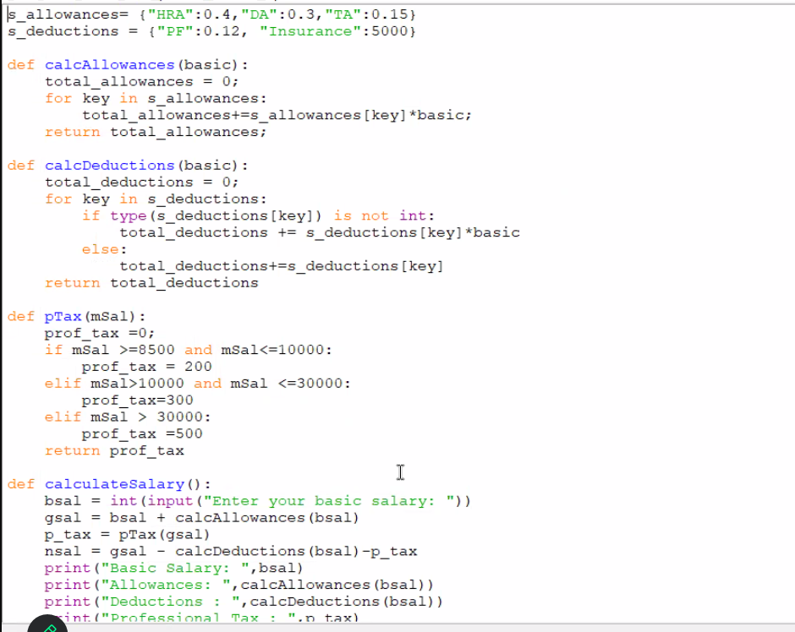

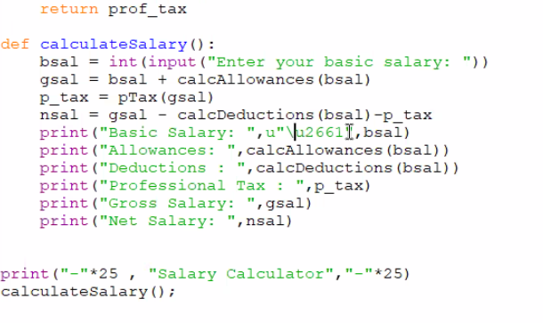

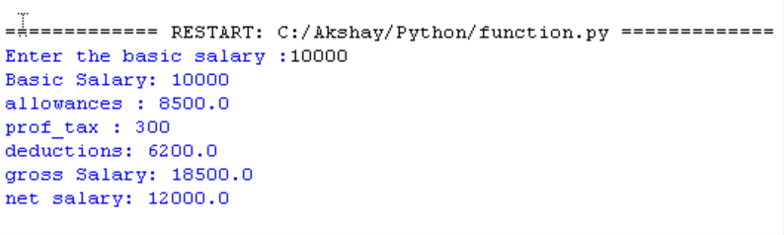

**IMPORT**

import random  
print(random.random()) # Output: A random float between 0.0 and 1.0

print(random.randrange(10)) # Output: An integer from 0 to 9 inclusive  
print(random.randint(1, 10)) # Output: An integer from 1 to 10 inclusive

colors = ['red', 'blue', 'green']  
print(random.choice(colors)) # Output: 'red', 'blue', or 'green'

numbers = [1, 2, 3, 4, 5]  
random.shuffle(numbers)  
print(numbers) # Output: [2, 5, 3, 1, 4] (or any other random permutation)  
print(random.sample(numbers, k=3)) # Output: [4, 1, 3] (without replacement)

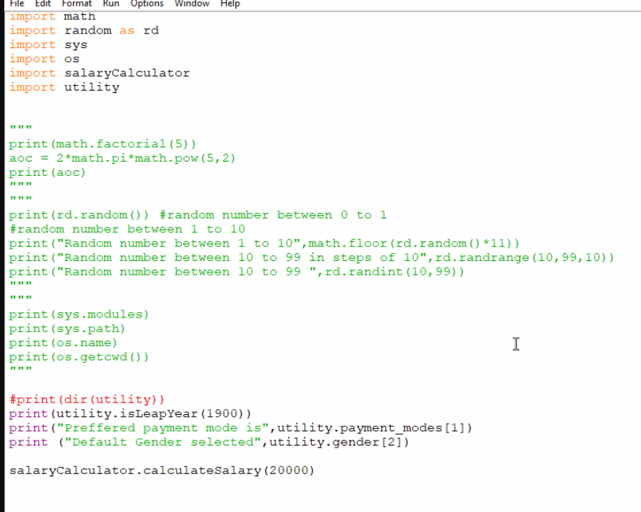

Utility  
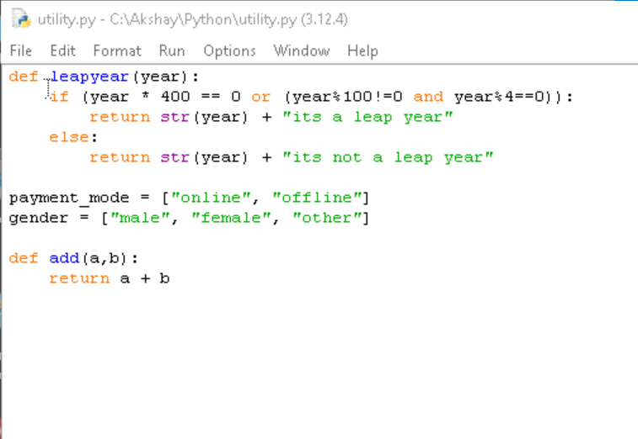

Output:  
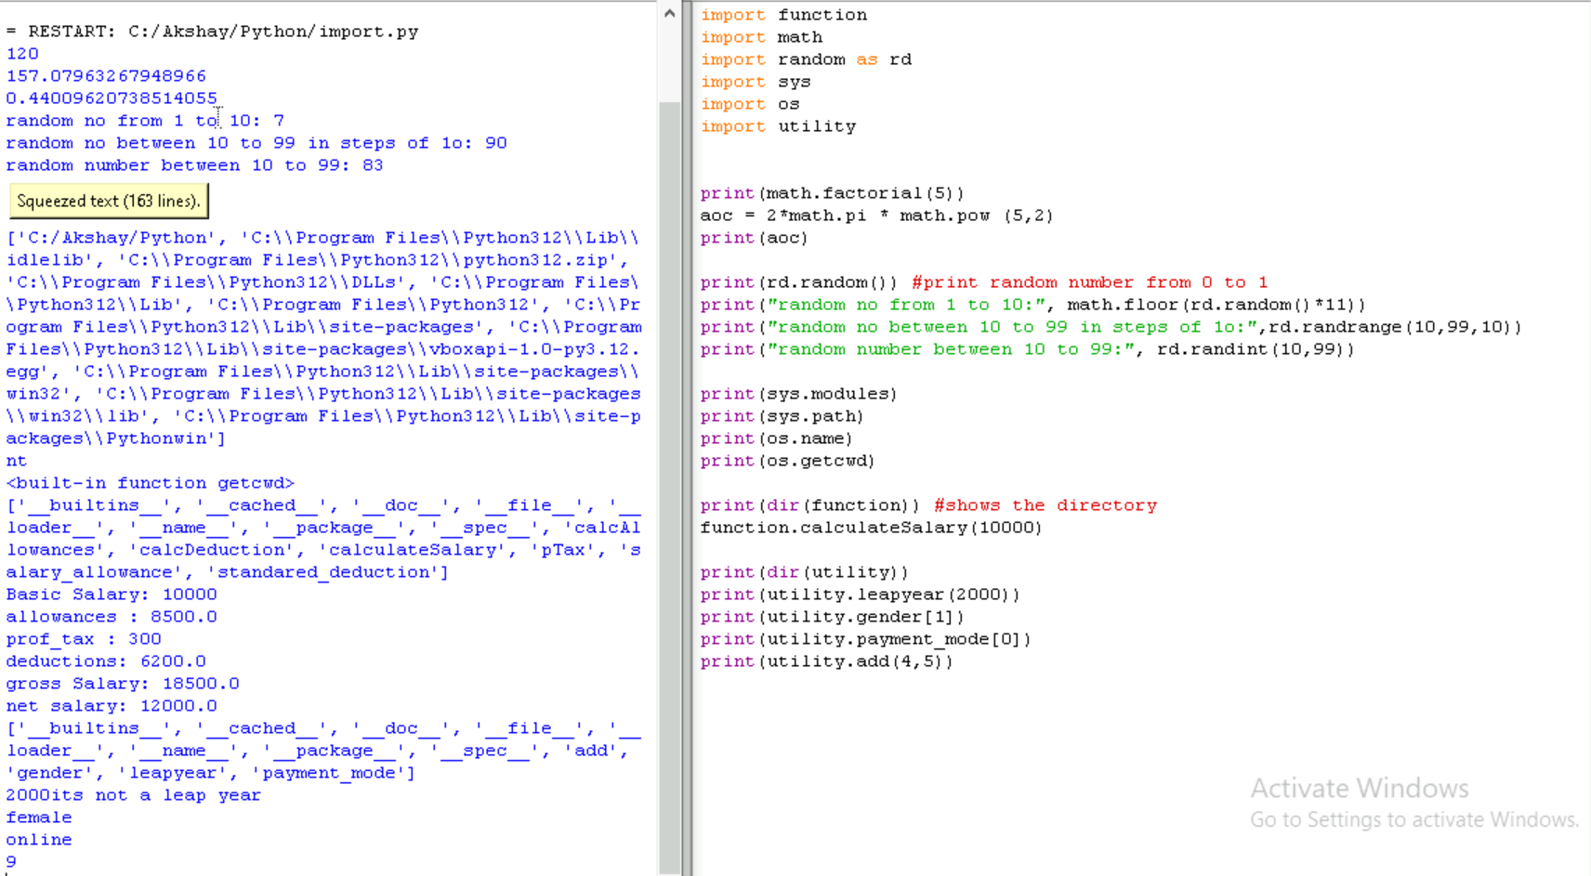

**FILE HANDLING**

Read, write, append method for .txt file

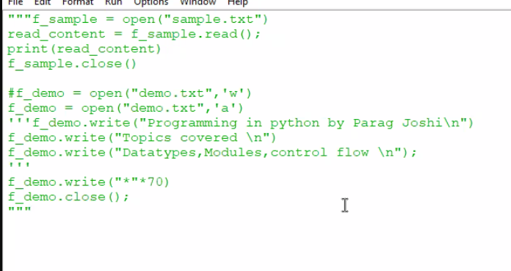

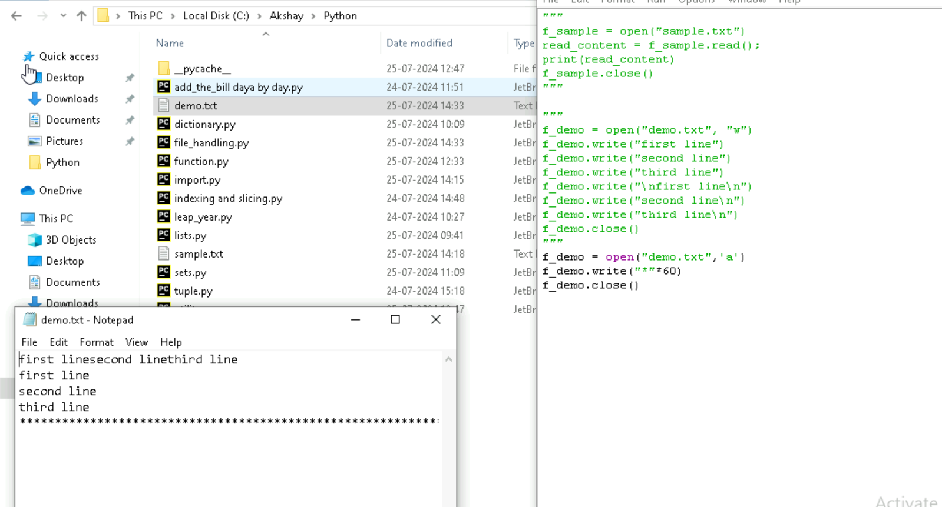

CSV file – which is , seperated  
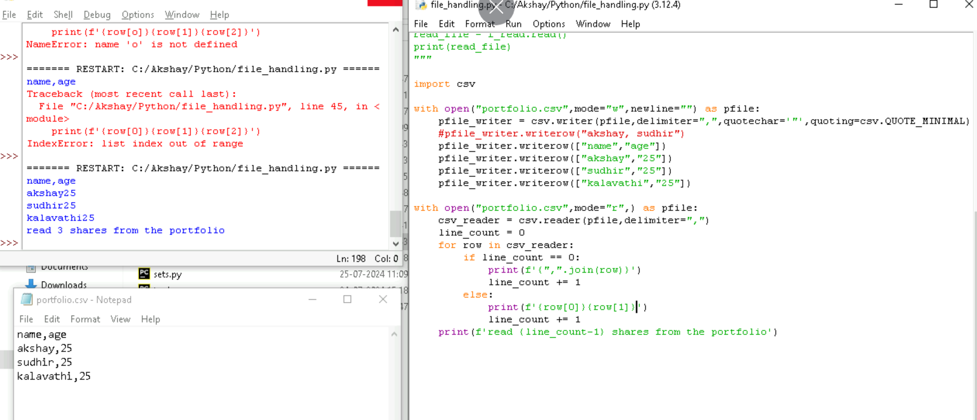

Adding data using variable

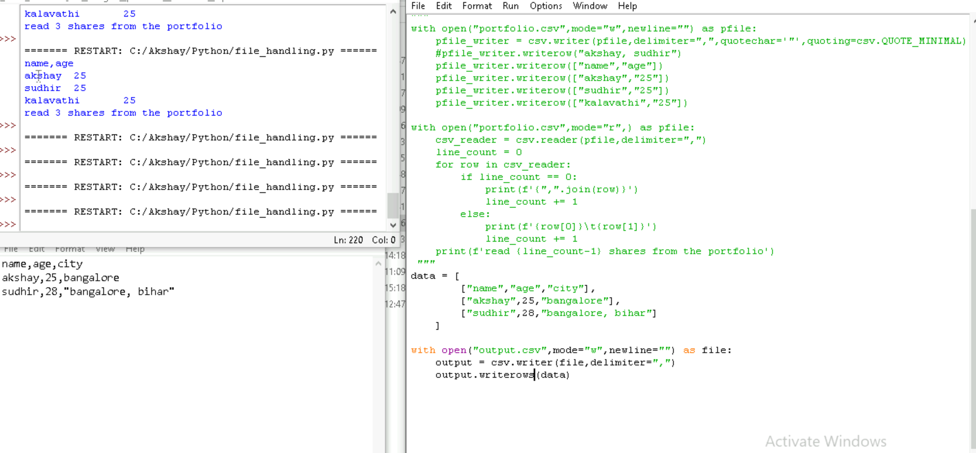

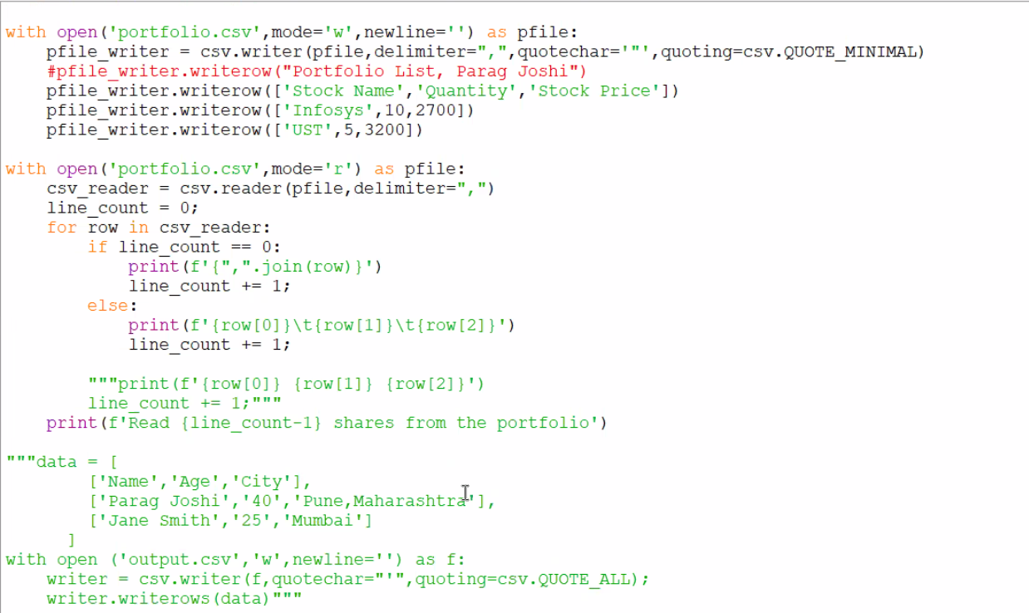

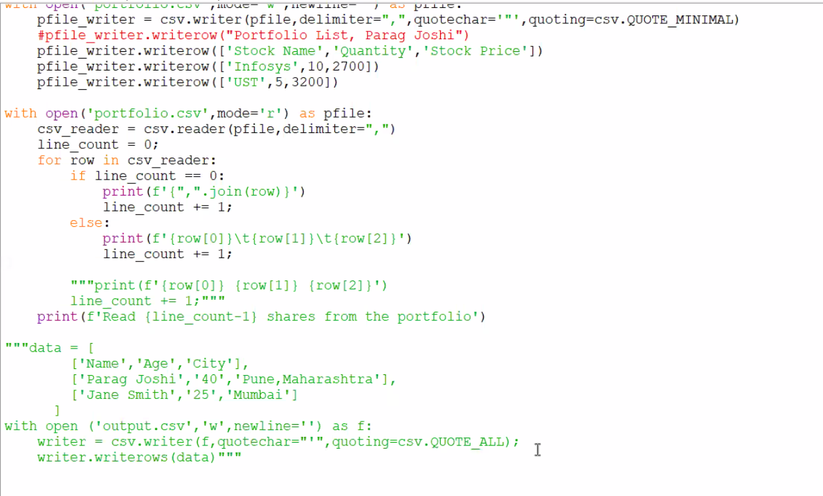

**EXCEPTIONAL HANDILING**

Exceptional handling is used when we want to show some error in a friendly way.

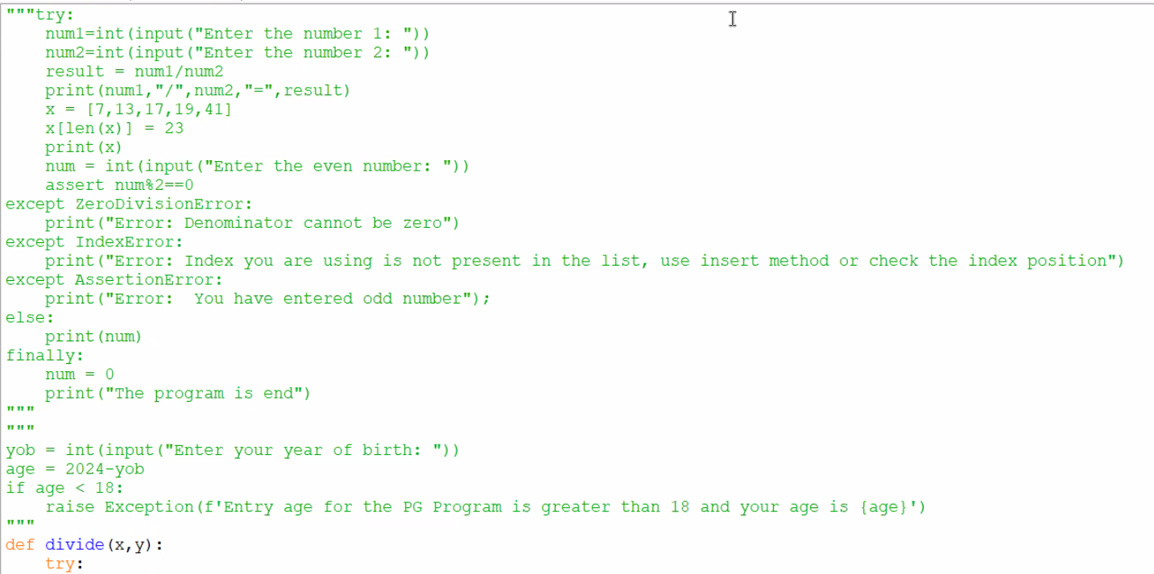

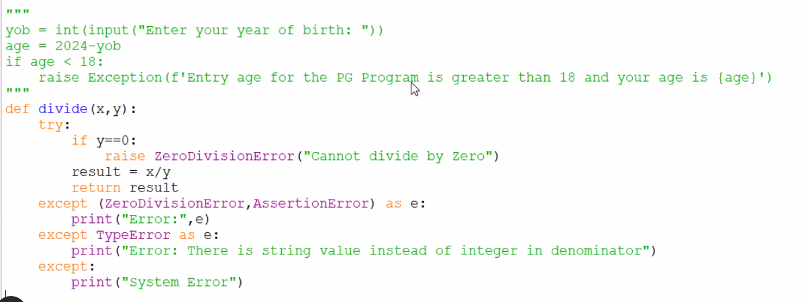

ASSESSMENT:

Question:

Define at least 6 items in your store with these 3 fields Itemid,Itemname,Itemprice

Whenever you start the program, ask the user the below menu

1. View the store

2. Purchase the item

3. Update the purchase item

4. Remove the item

5. View the purchased item list

6. Exit and Generate Invoice

if I entered input as 2, I should be asked the itemname or itemid , quantity to purchase after I enter it should be added into my shopping cart (i.e itemlist), then user should be asked if he/she wants to continue adding the items , if yes then you should be asking the the itemname or itemid , quantity to purchase after I enter it should be added into my shopping cart (i.e itemlist)

if he/she says no.. you should showing them a main menu i.e. above

if he enters 3 then you should ask itemid/itemname to be modified after he enters itemid/itemname you should ask the quantity to be updated after quantity is entered the itemid quantity and price should be updated for that item.

if he enters 4 then you should ask itemid/itemname to be removed. After he/she enters itemname that should be removed from the itemlist

if he enter 5 then you should show the itemlist he has purchase with the following format 1. Maggi 10 20 200 2. Butter 2 150 300

if he enters 6 the you should be exiting the program and save the bill in the file invoice.txt in below format

***** Invoice Copy *******

1. Maggi 10 20 200

2. Butter 2 150 300

Total: 500 """

Solution

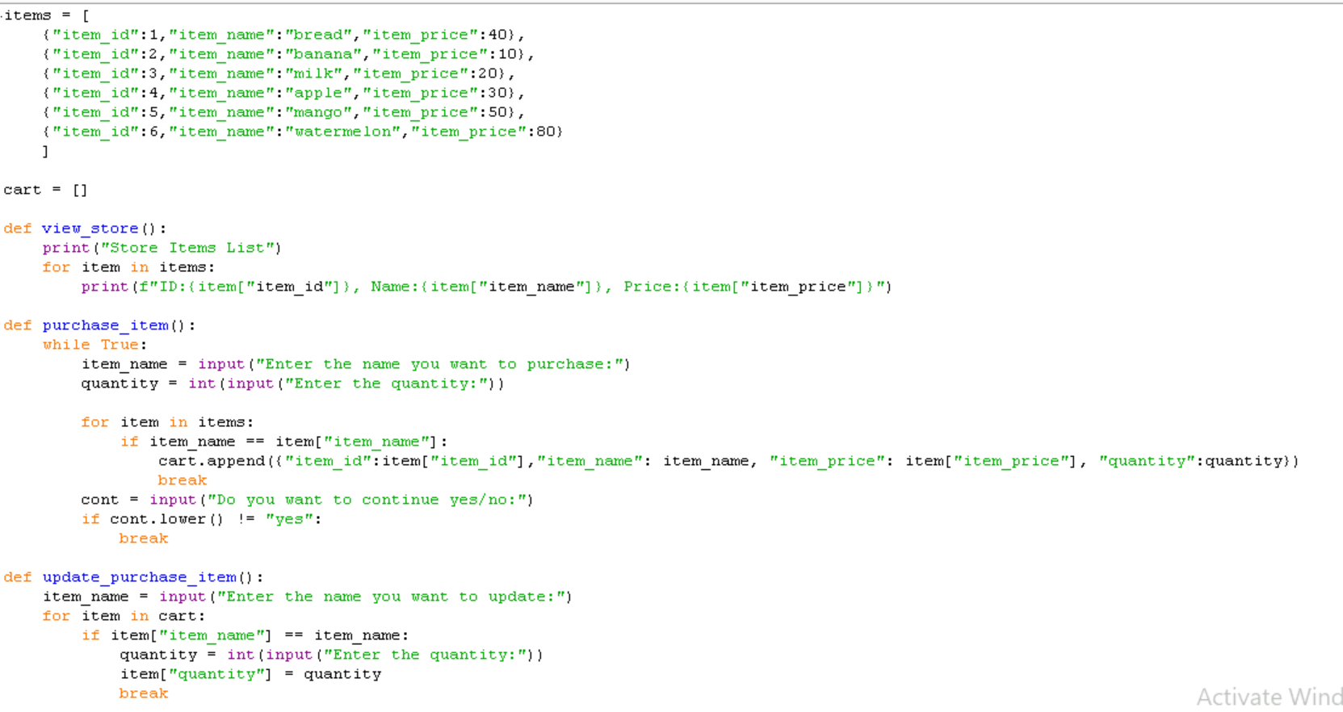

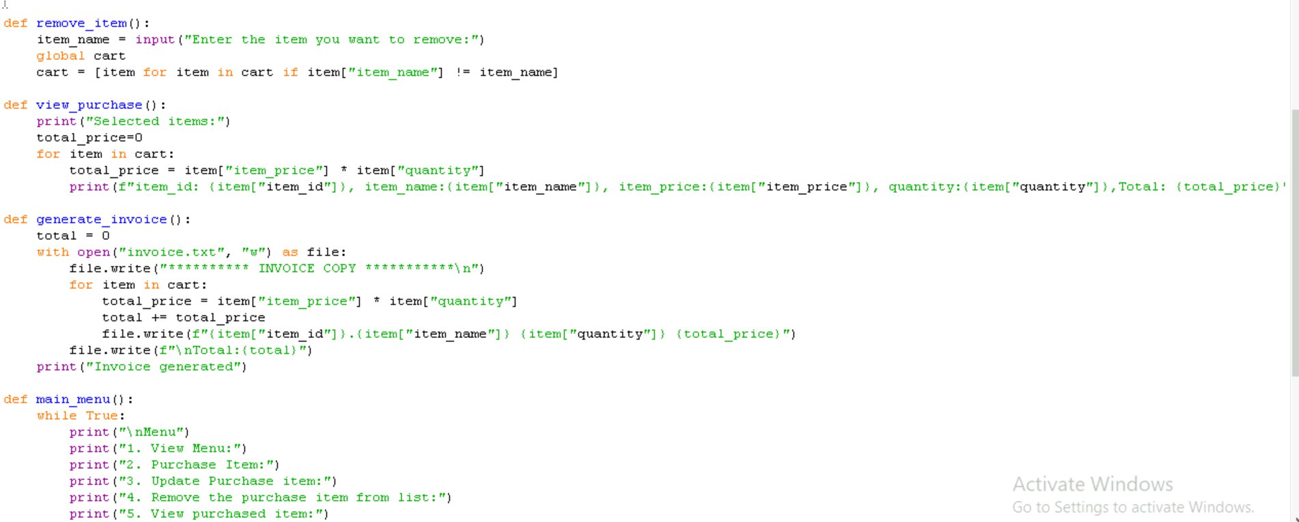

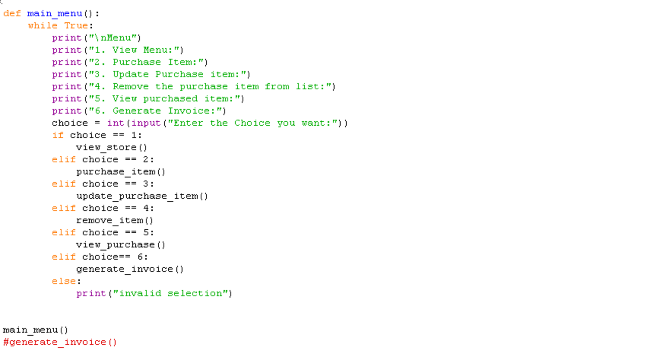

**COLLECTION**

Collection is library its like sets tuple dictionary and list.

Collection is library and we can import nametuple, deque, chainmap, counter, ordereddict, defaultdict

**Namedtuple and deque**

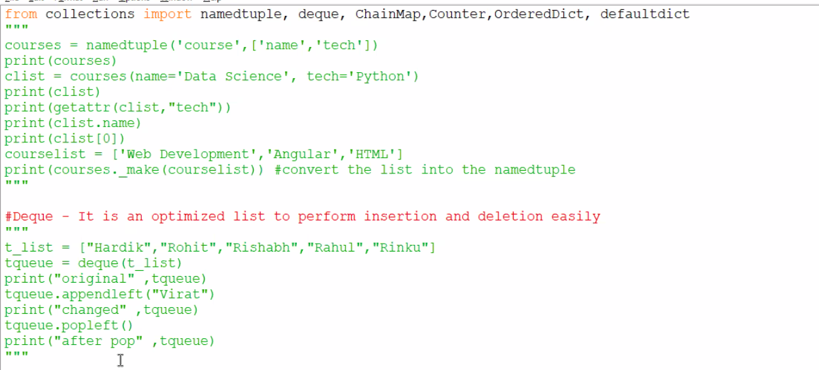

**Chainmap dict**

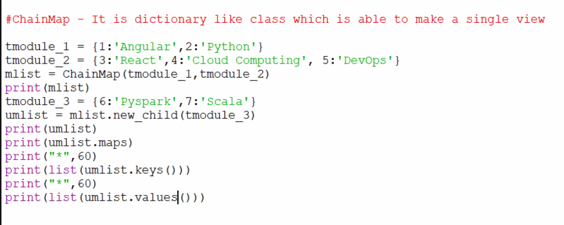

**Counter dict**

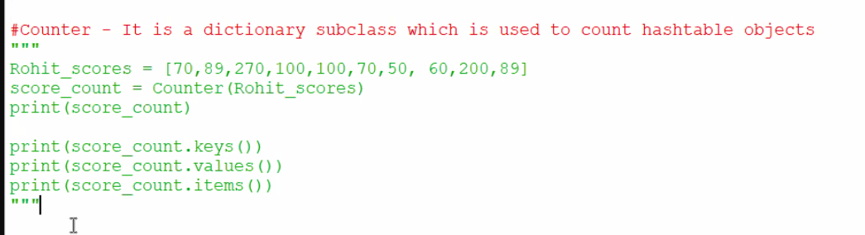

**defaultdict**

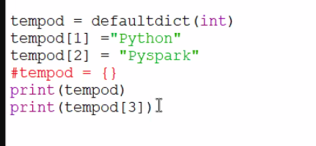

**Ordered dict**

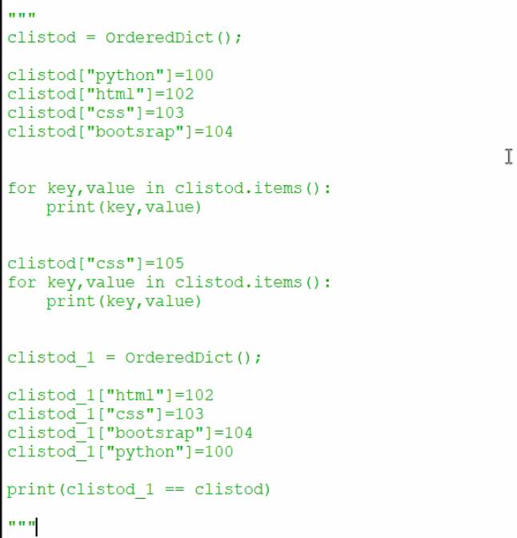

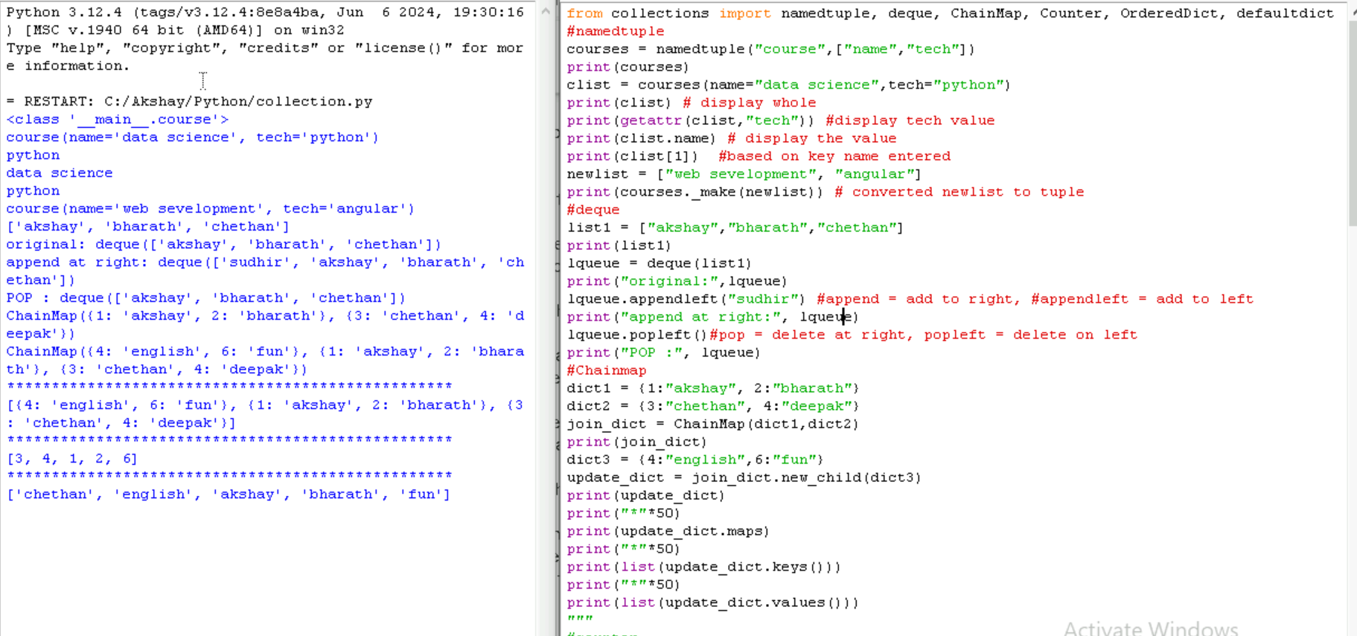

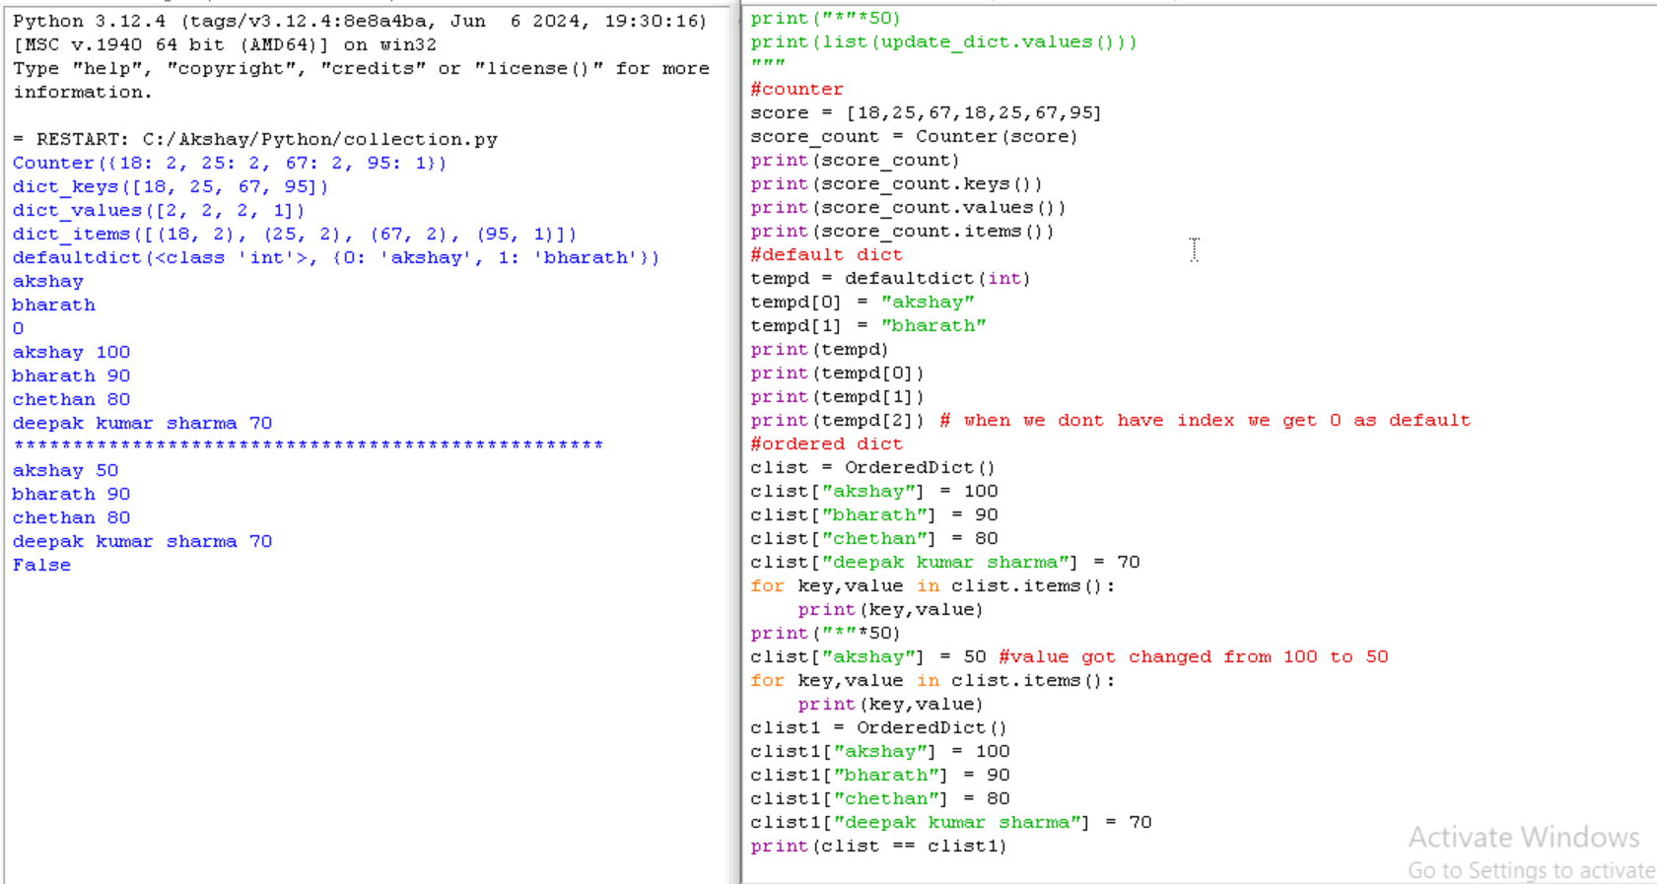

NOTE : to print date and time we can use this code for knowledge purpose

**CLASS in PYTHON**

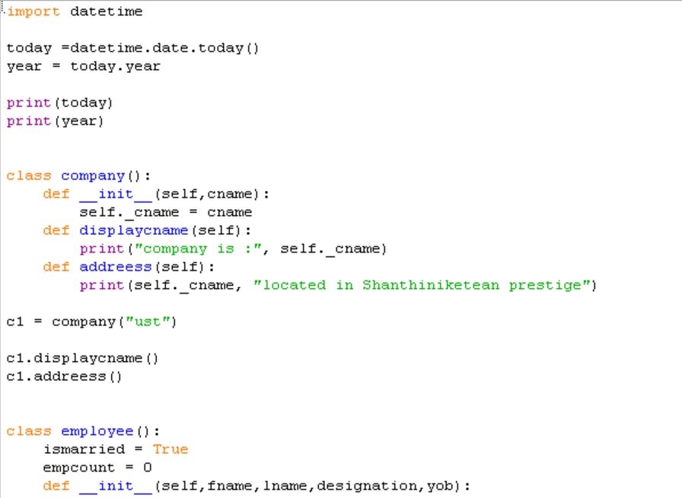

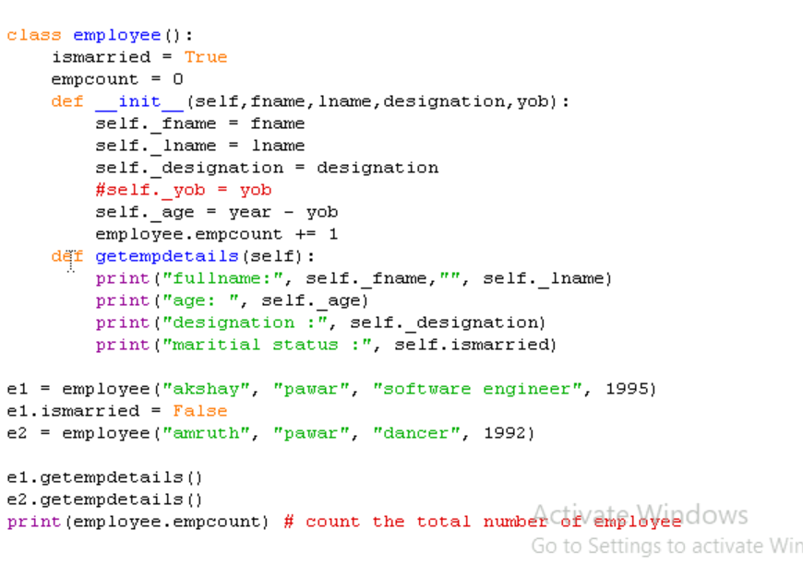

Inheritance and polymorphism (see the Employee details)  
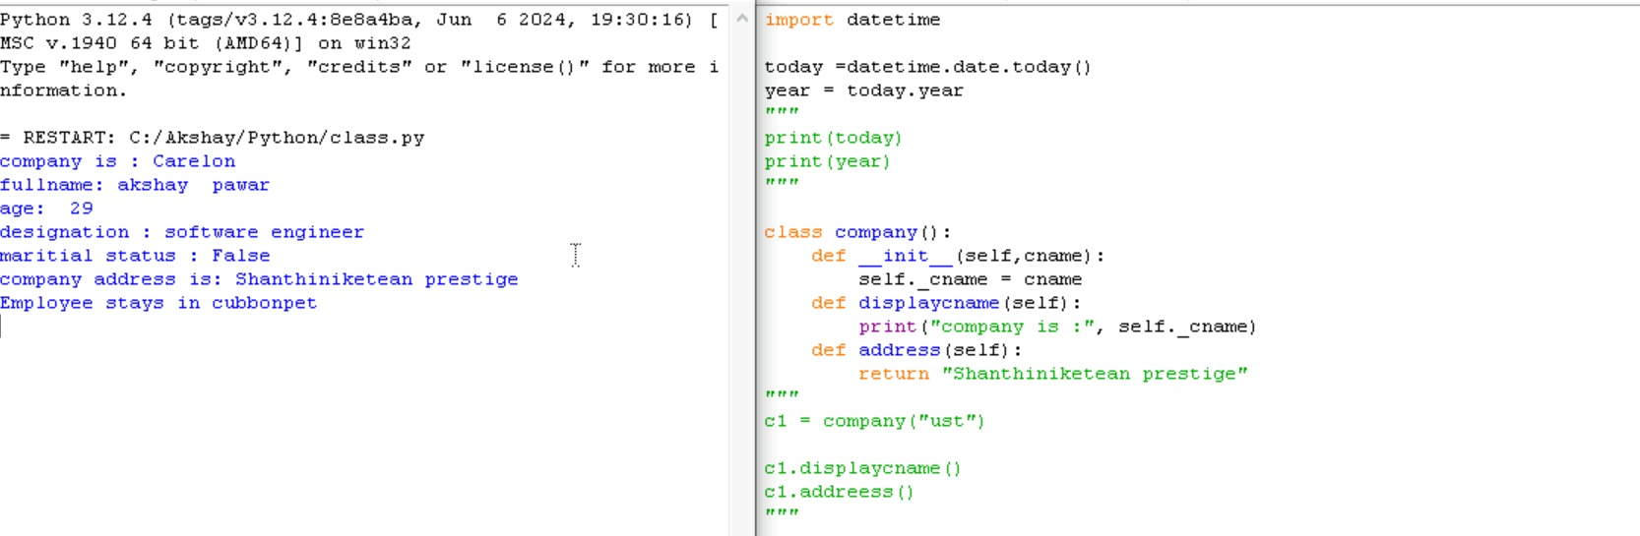

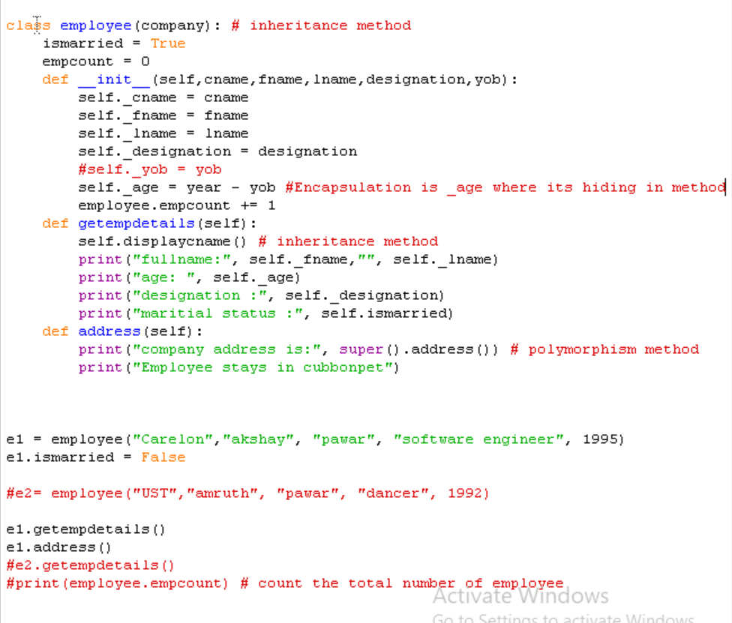

**ITERATORS & Generators**

Iterators is a method that are iterate collections like list tuple etc.

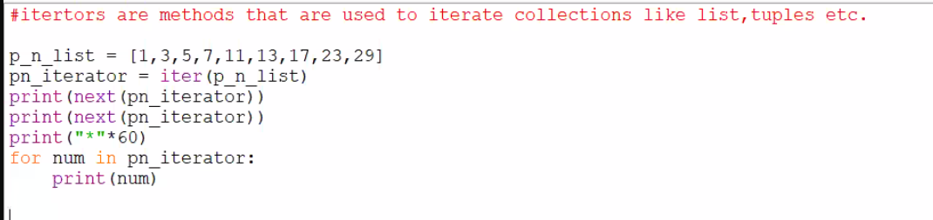

Generator is a function that returns an iterators that produce sequence of a values when ever it is iterated over

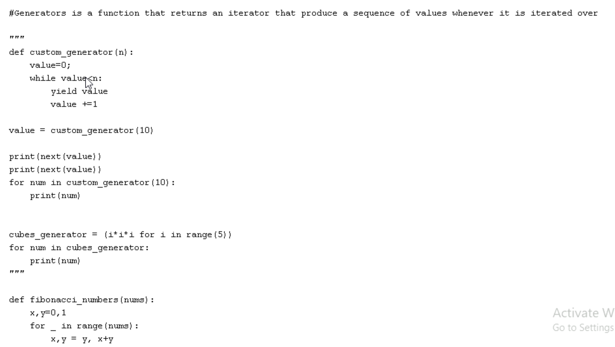

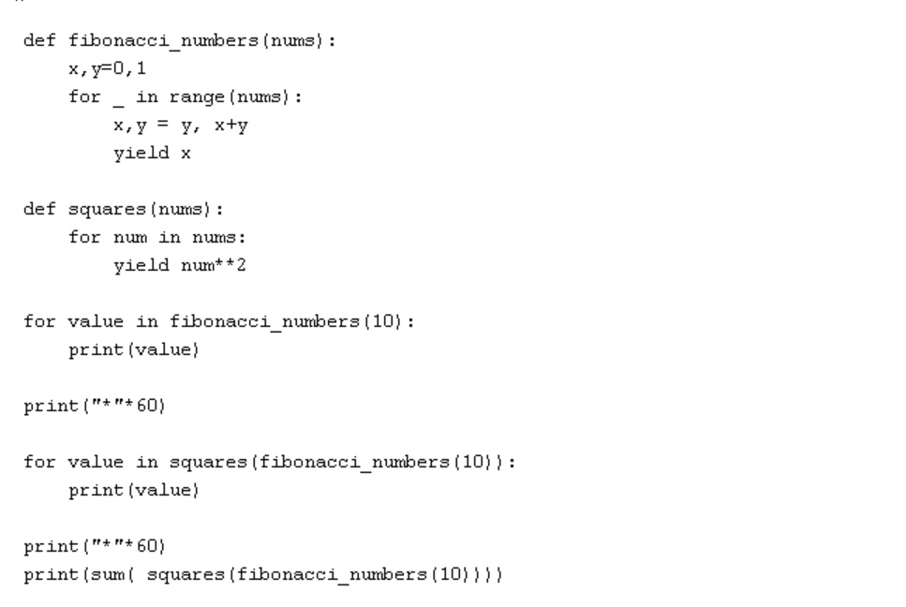

**Salary calculation using class**

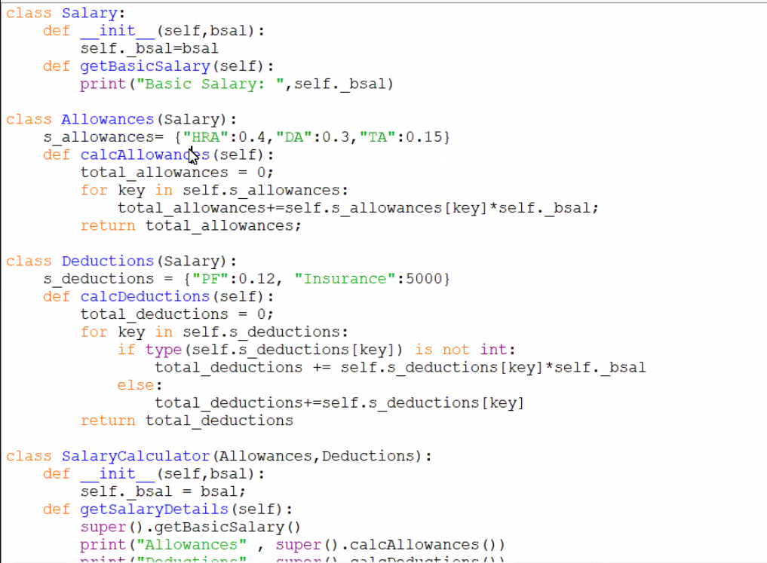

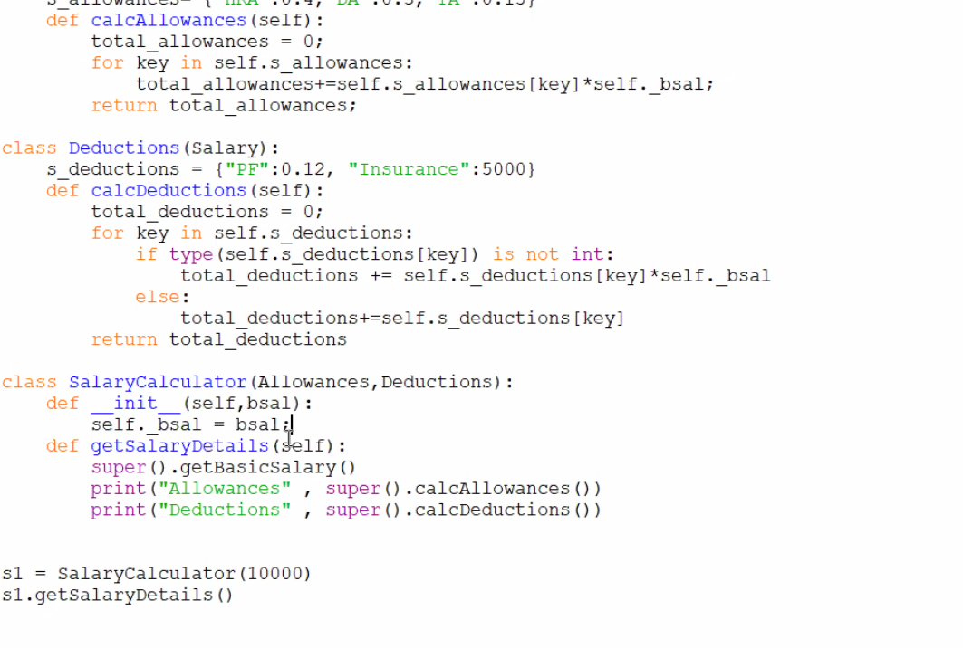

Mycode  
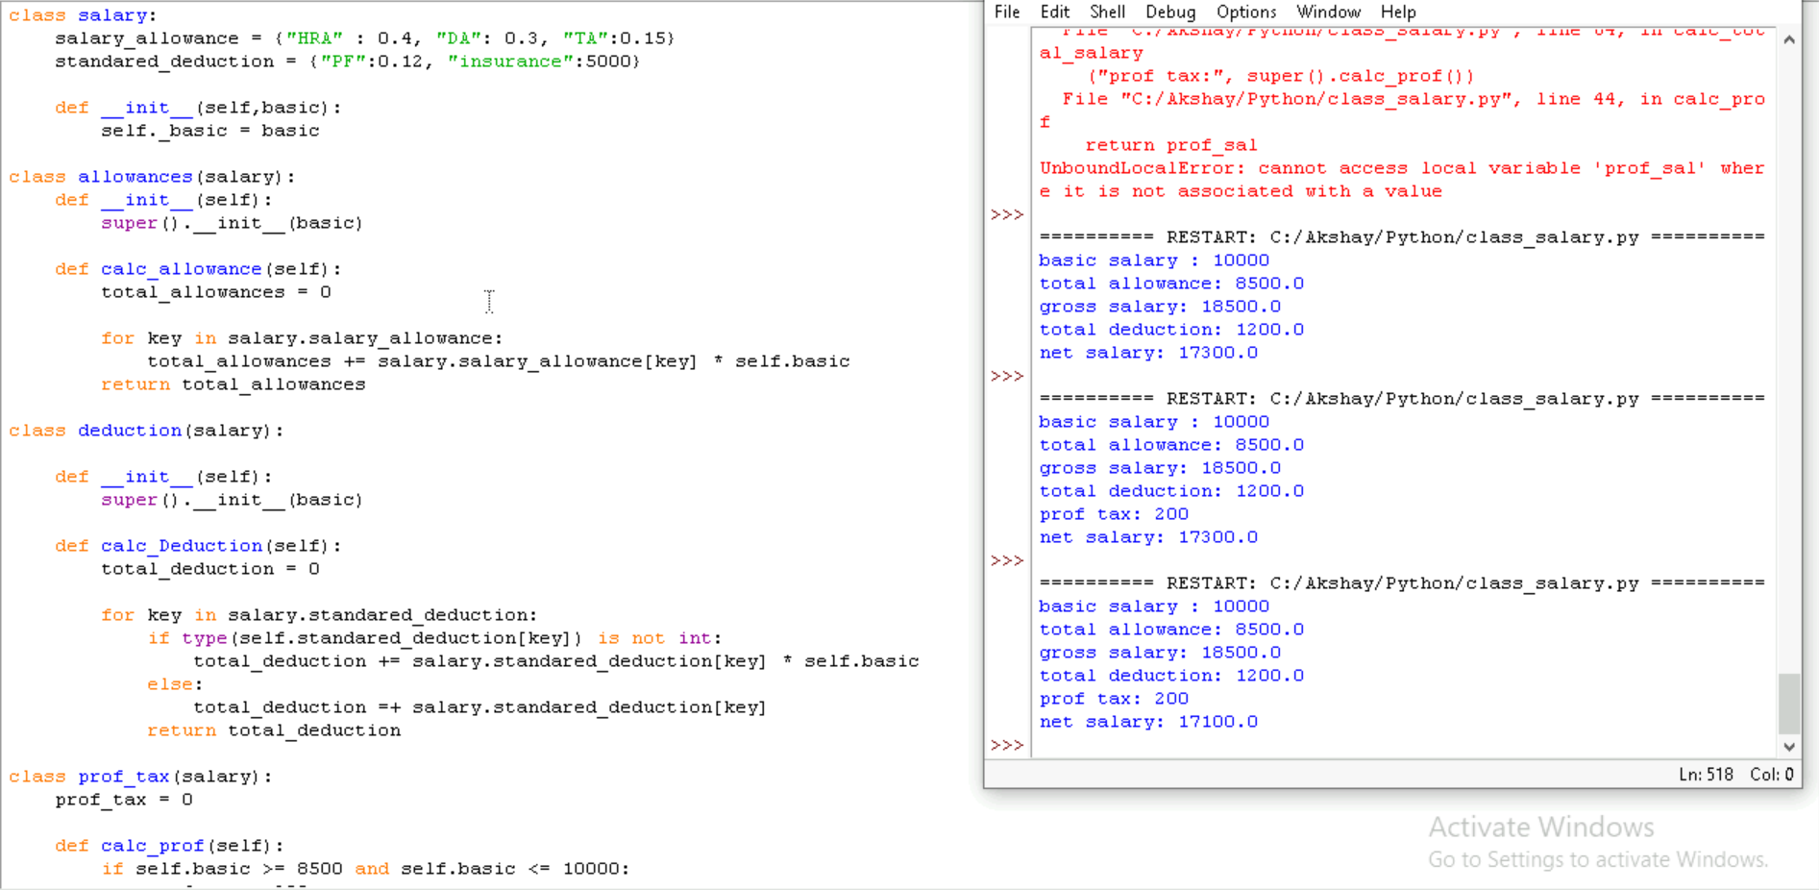

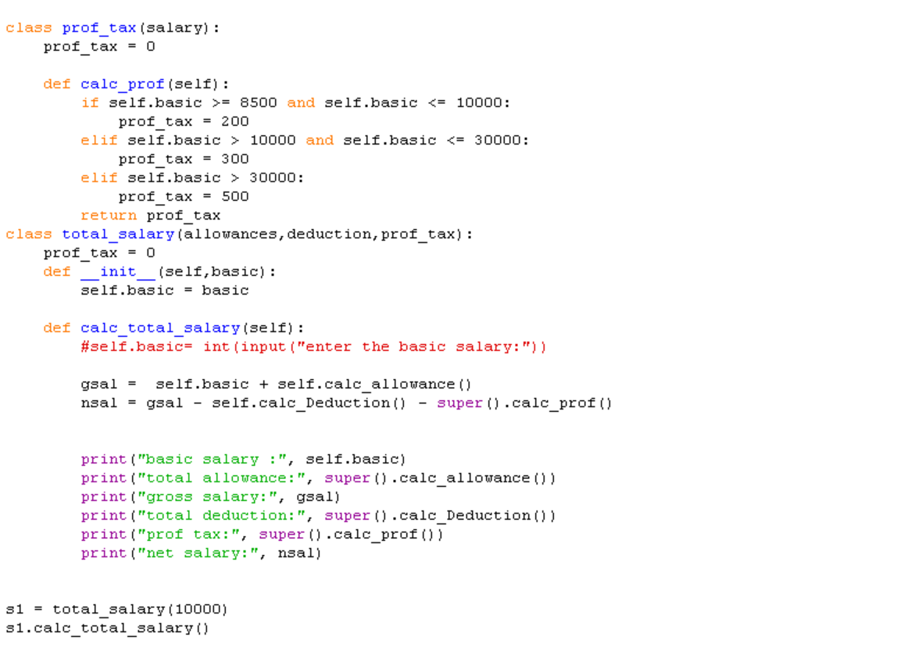

**PYTEST**

To install pytest( pip install pytest )

To create environment ( python -m venv foldername )

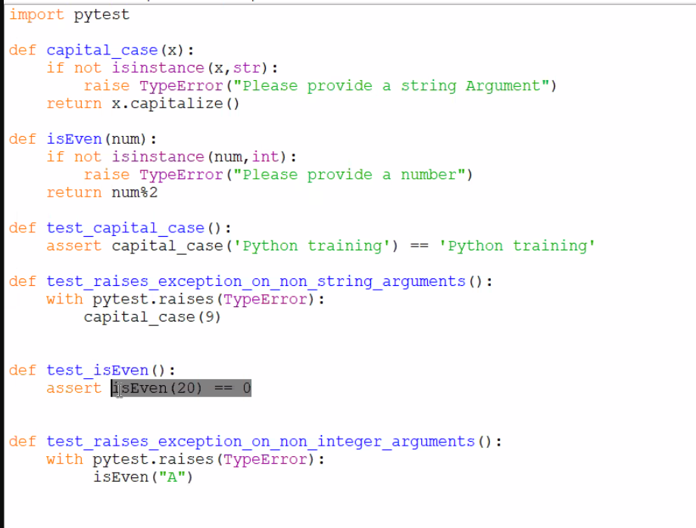

To run the test in the script directory write (pytest filename ) to run the test case else we can give pytest and keep the file naming start with “Test” ex: Test_demo.py

Practice 2 :

Wallet.py  
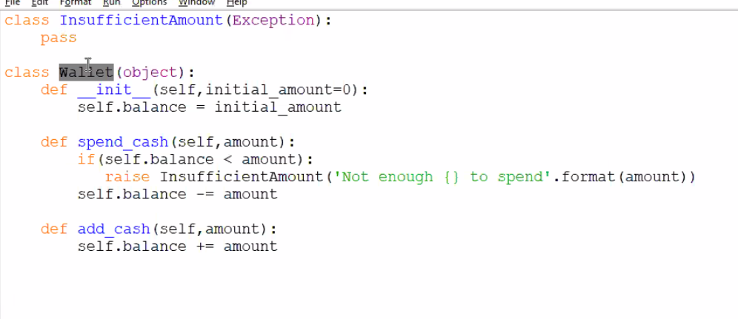

Test.wallet.py

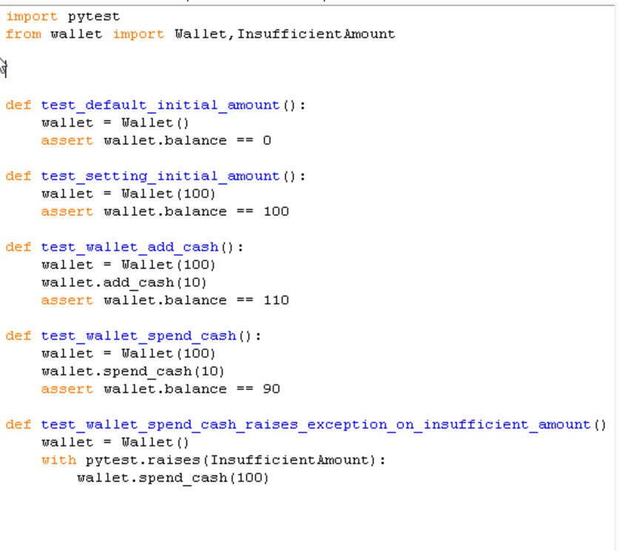

Instead of using same variable again and again we can use Pytest_fixture  
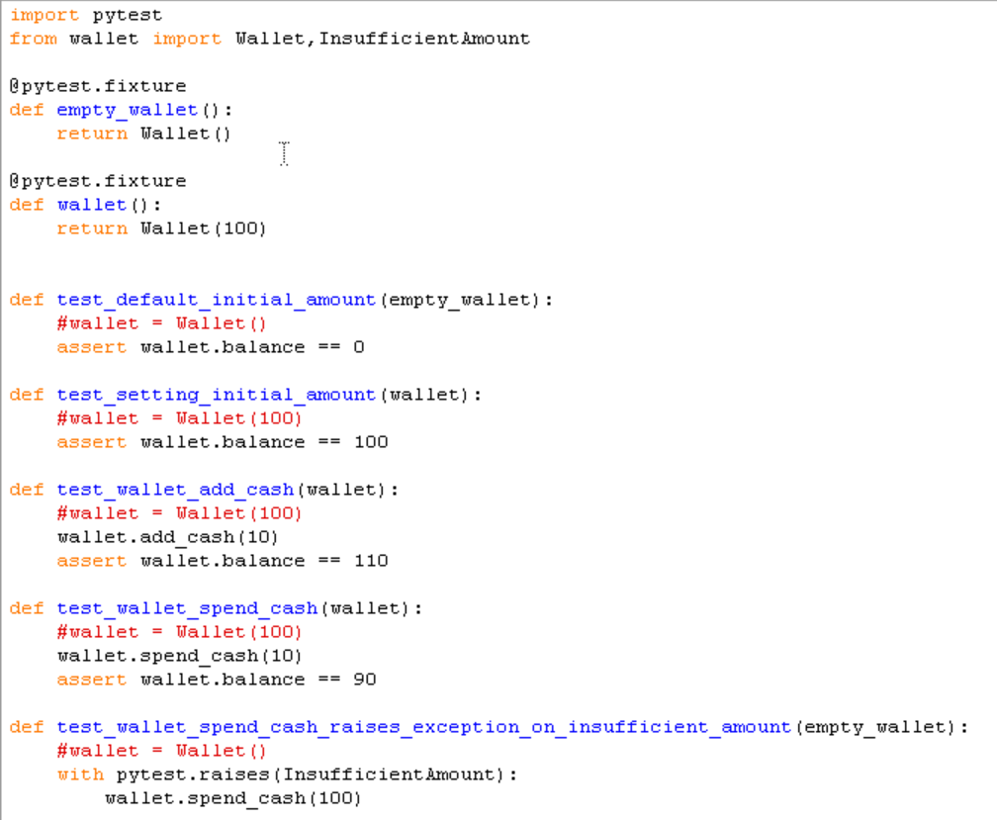

@pytest.mark.parameter

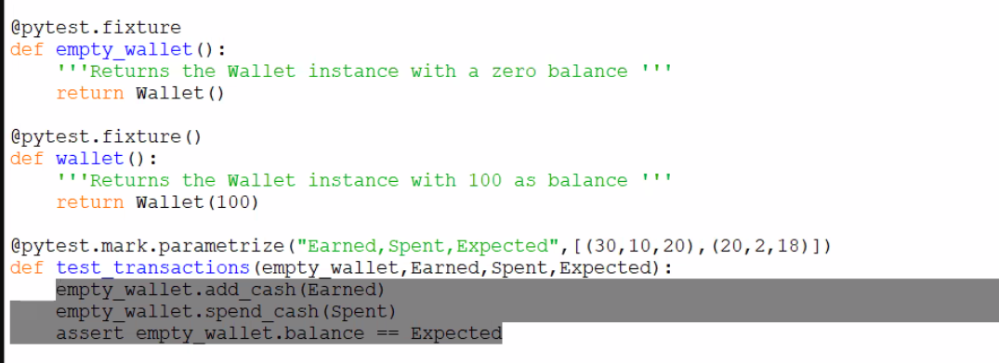

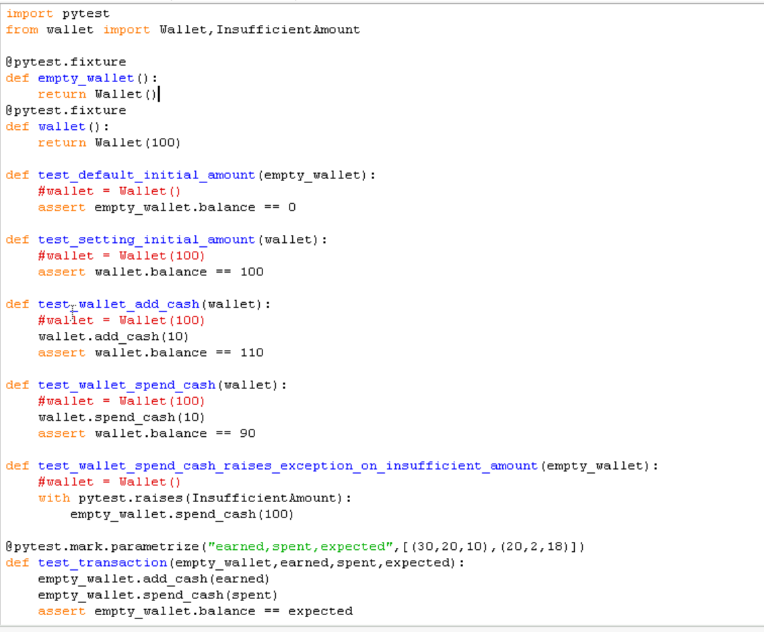

**NUMPY**



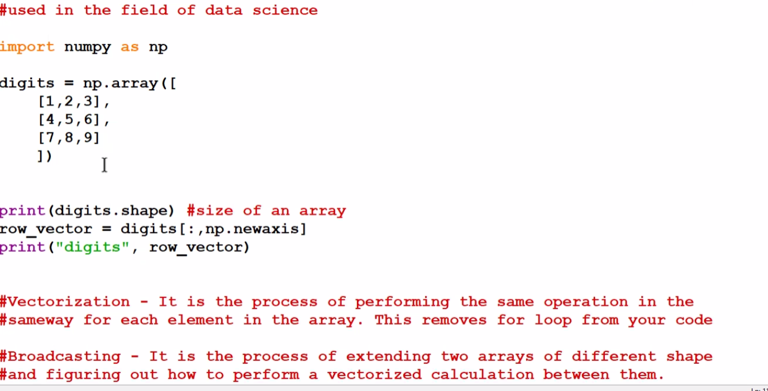

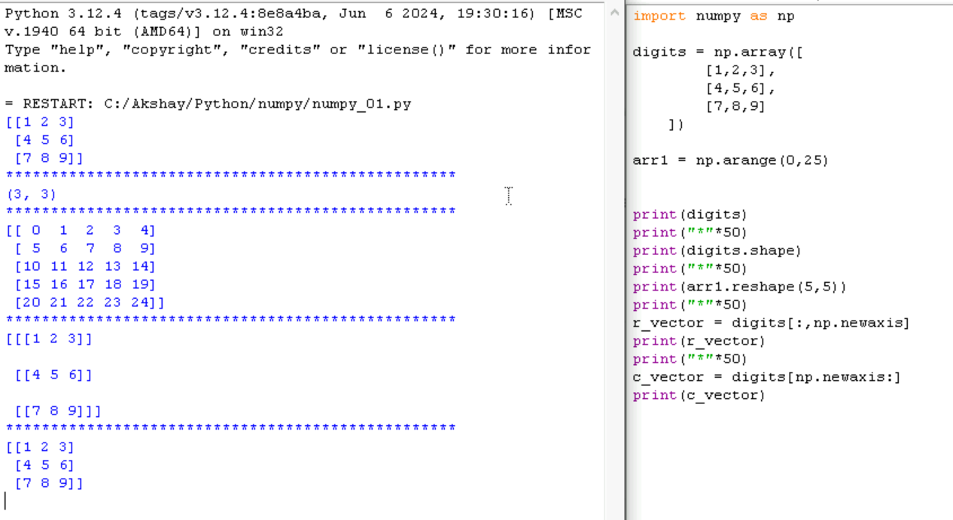

Benefit   
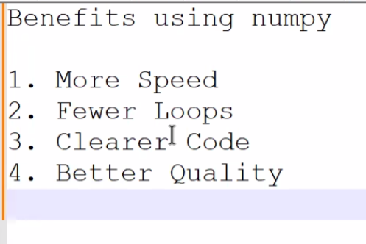

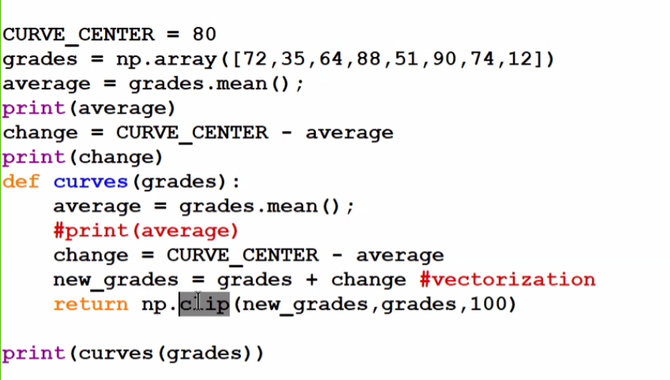

Clip = compare first 2 arguments that is new_grades and grades and it shouldnot be more than 100 and give the out which is greate

Mean() = it gives average value

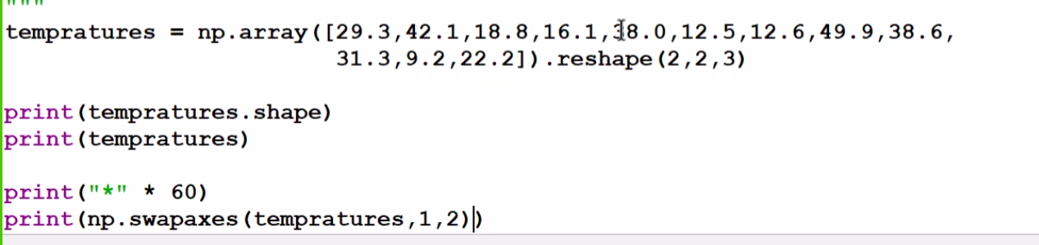

Swapaxes = it will swap from row to column

Swapaxes = 0,1 means 2 dimension swaps …. 1,2 means 3 dimension swaps

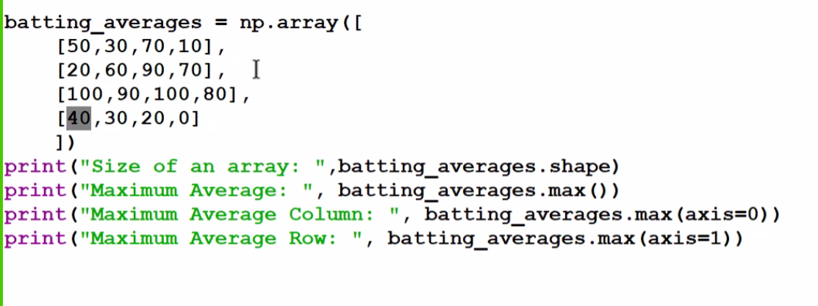

Axis = 0 🡪 column

Axis = 1 🡪 row

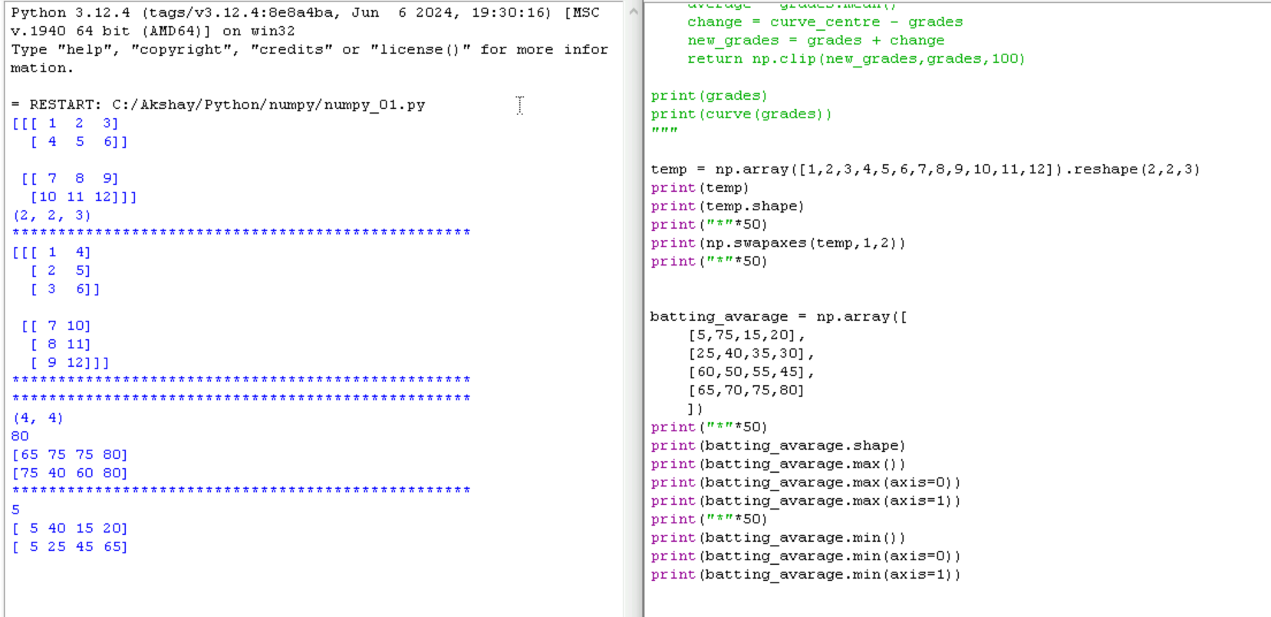

Linar space   
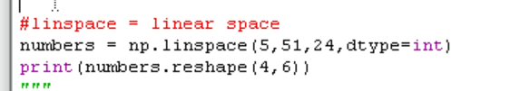

Arthimetic arrange  
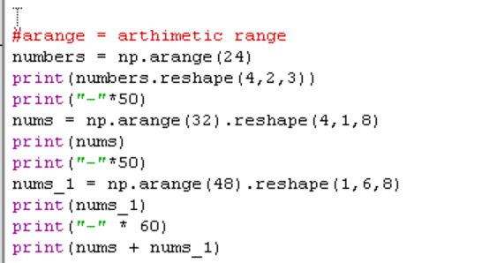

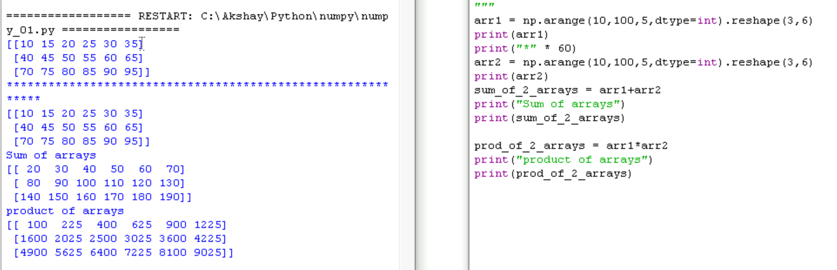

To get value true or false

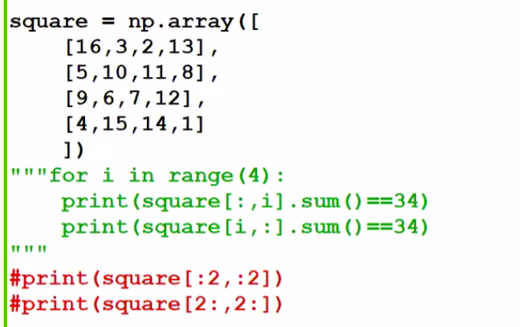

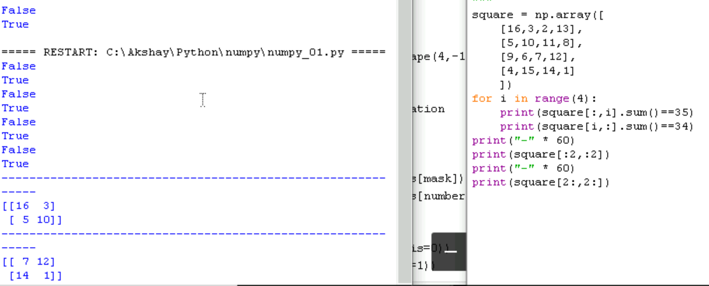

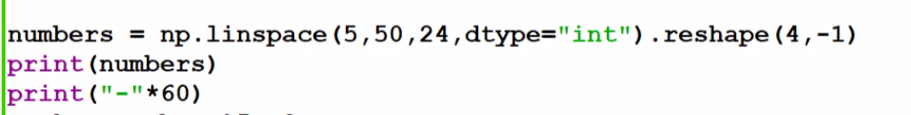

When not sure on rows or columns we can give -1 value

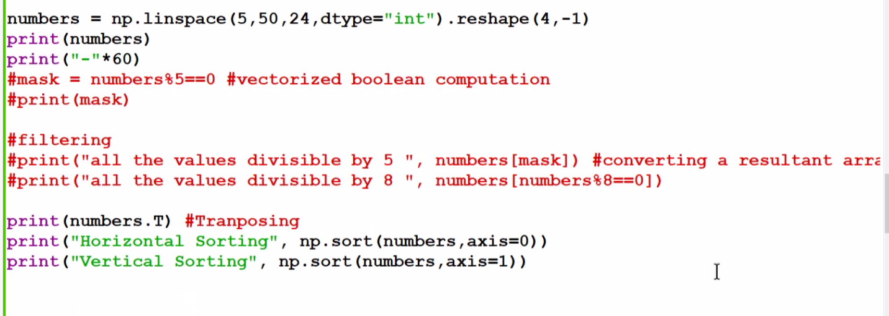

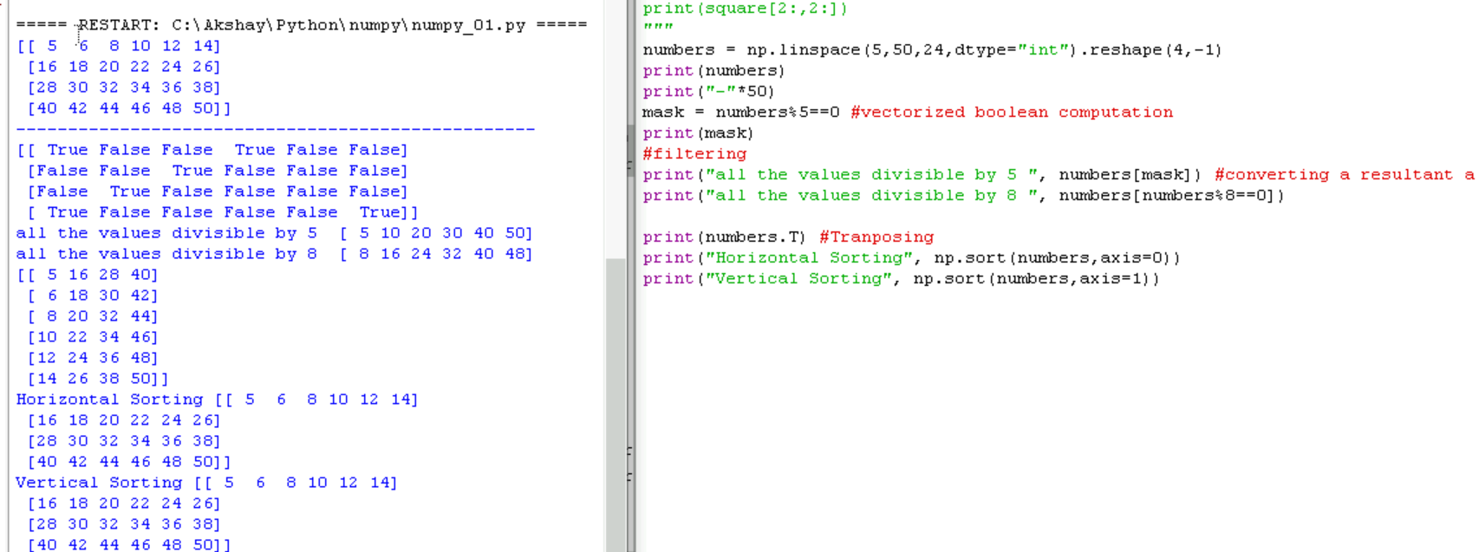

We can do the filter data using above condition

Print(mask) 🡪 wil give true false value

Print(numbers[mask]) 🡪 will get value which is true

Print(numbers.T) swap from row to column and column to row

Np.sort(numbers,axis=0 or 1)

Concatenation 2 arrays into 1

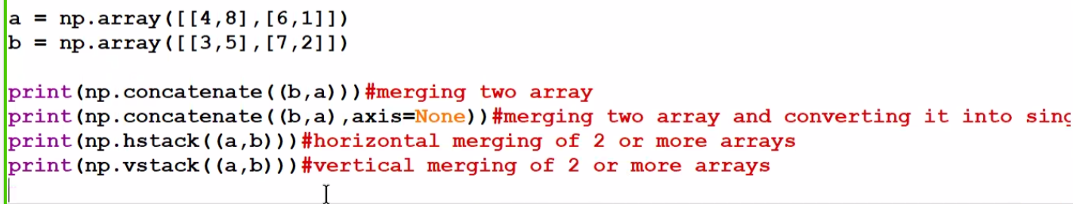

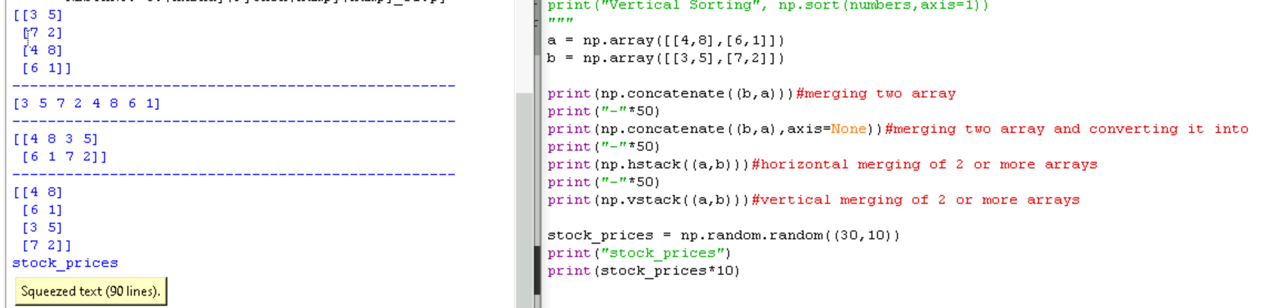

Axis= none 🡪 merge 2d array to 1d array

Hstack 🡪 horizontal stack merging

Vstack 🡪 vertical stack merging

Numpy Exercise click on the document:





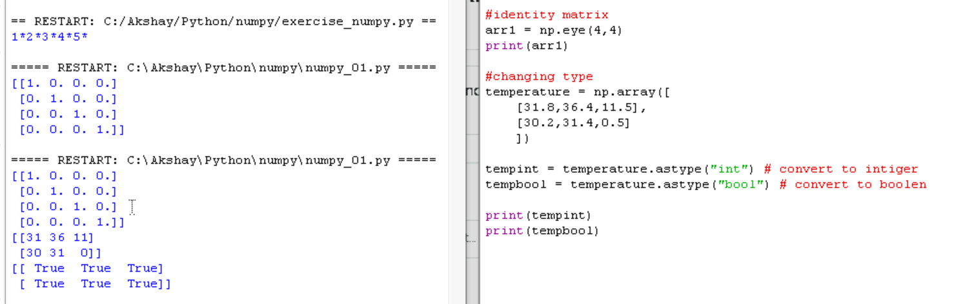

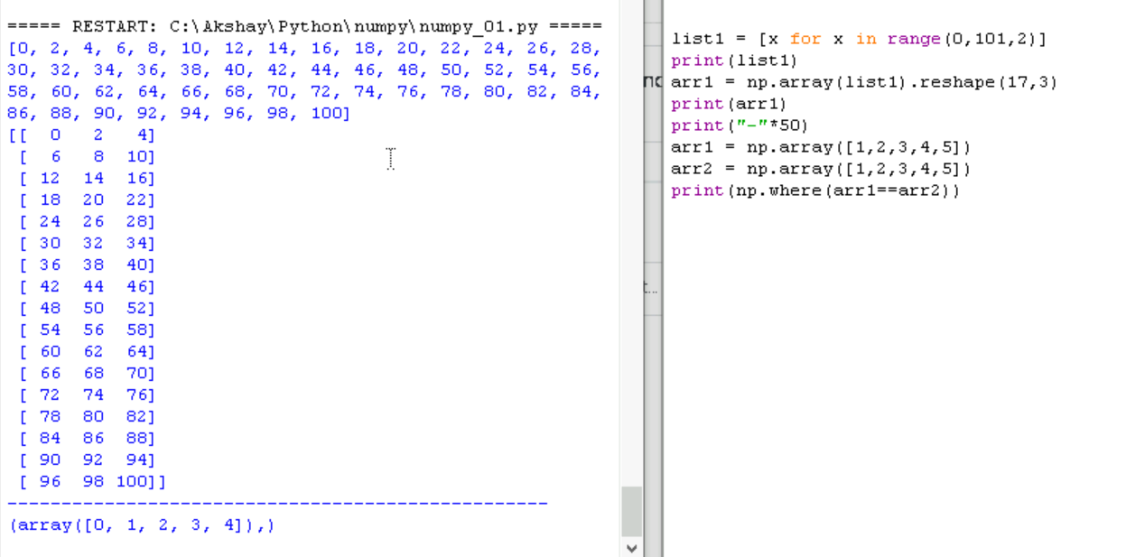np.where it gives the output index wise where value is mathcing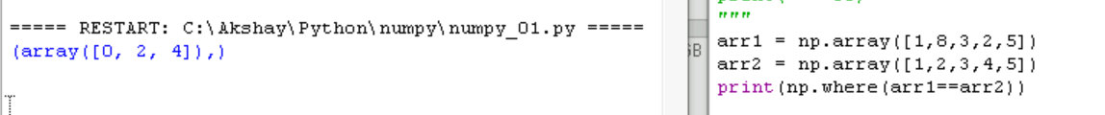

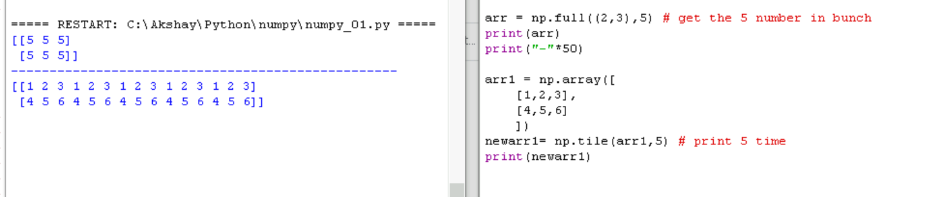

random

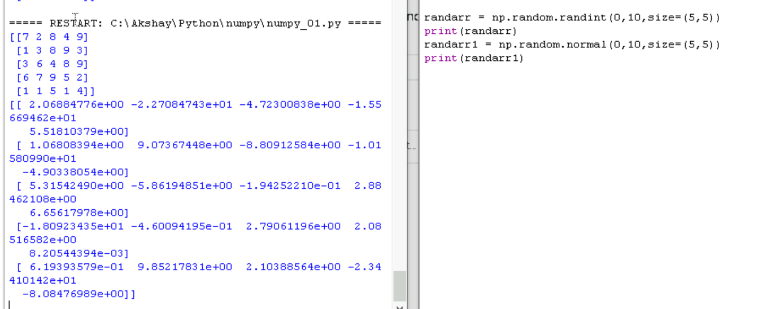

Sorting with index value

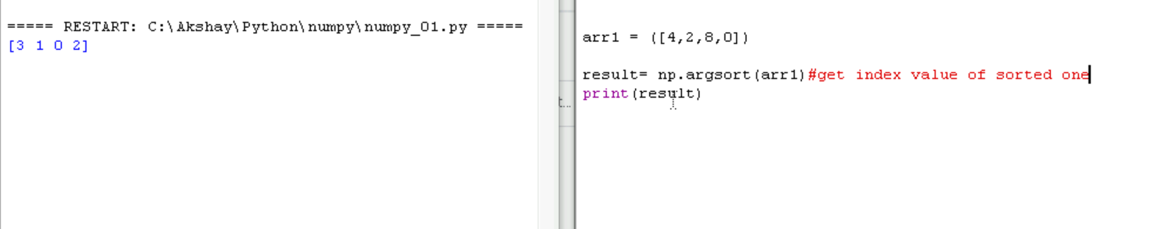

Np.all 🡪 if arr> 4 if all value in array is greater than 4 then TRUE else FALSE

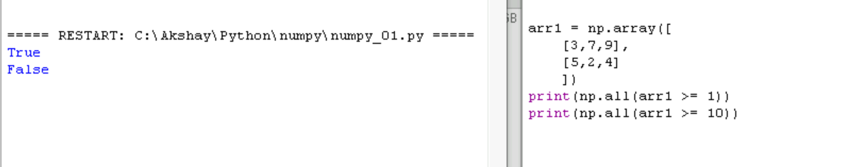

**PANDA**

Panda is used for data analysis purpose.

It is very very useful package in python , which helps in data clearing

Advantage:

Creates structure of data similar to excel sheet

Read the data from multiple format like csv, txt, xls, sql database

Select rows and column from dataset

Arrange data in assending and descending order

Filtering data

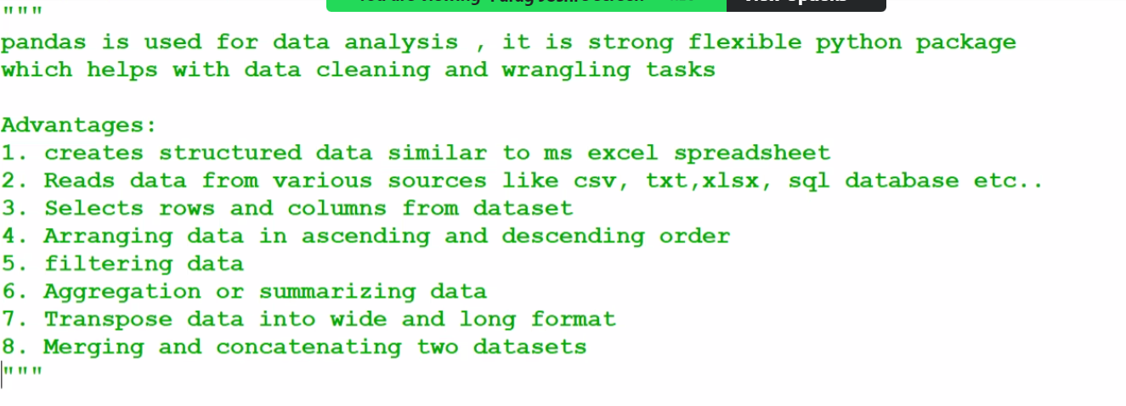

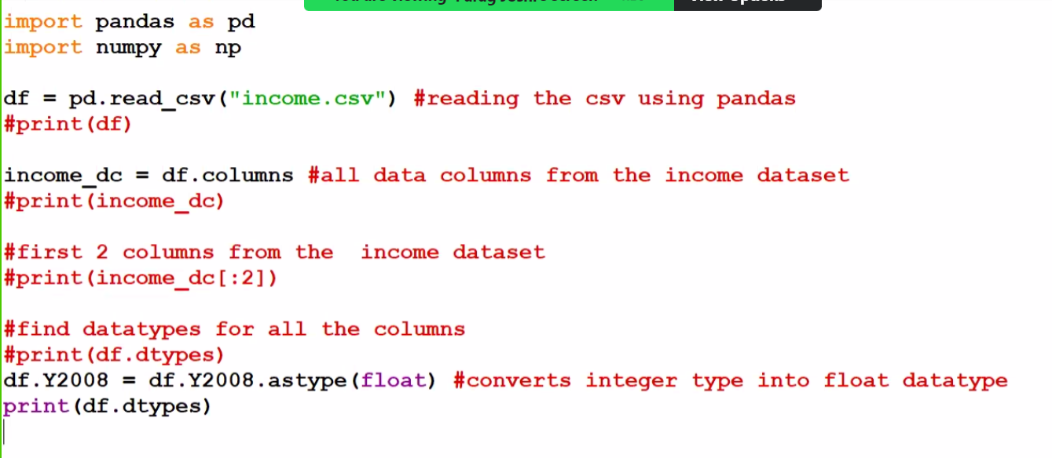

Print(“to find rows and col :” df.shape)

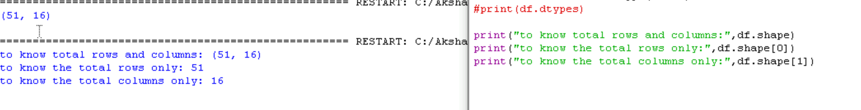

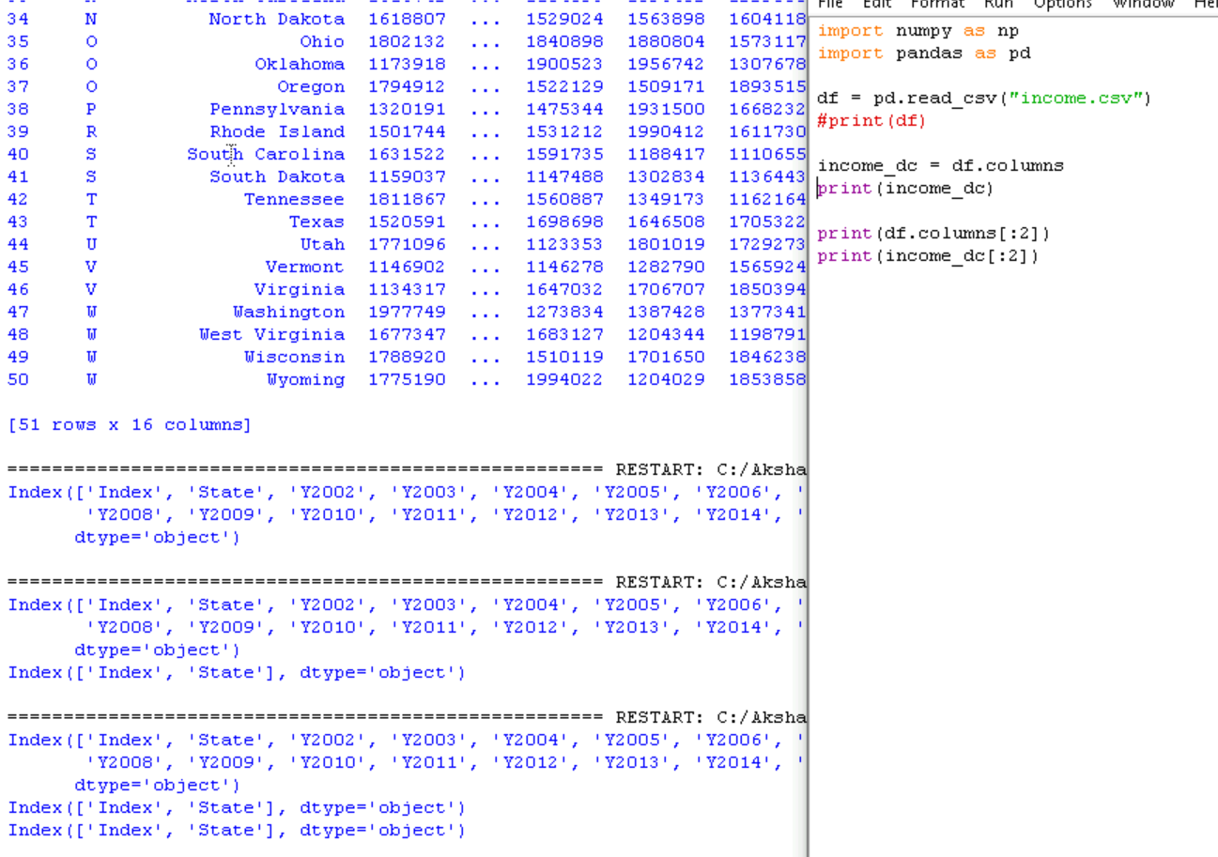

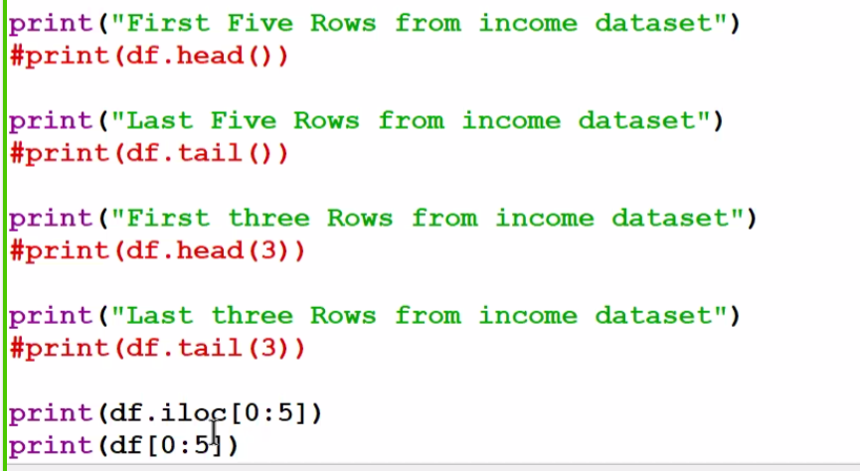

By default 5 will get , if we want specific number we can specify in (3)

Iloc 🡪 we can slice = index loaction

0 🡪 rows

1 🡪 columns

To find unique values

Df.nunique() 🡪 it gives unique count for each column

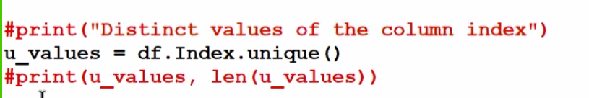

Link between stats and index compare between index and stats

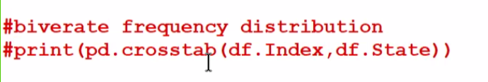

Finding Indexing count which is repeated, we can use ascending and decending

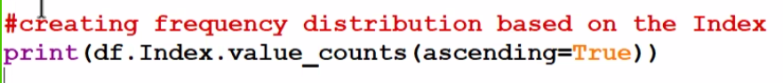

Df.sample(N=10) 🡪 get 10 random data

Df.sample(frac=0.1) 🡪 get 10% of random data

Print(**data[“columnname’] or data.columnname**) both works to fetch 1 column

Print(df[[‘column1’,’column2’,’column3’]])

Data = df.loc[:,[“column1”,”column2”]] 🡪 :, means all rows 1:5 means from 1 to 5 row will get

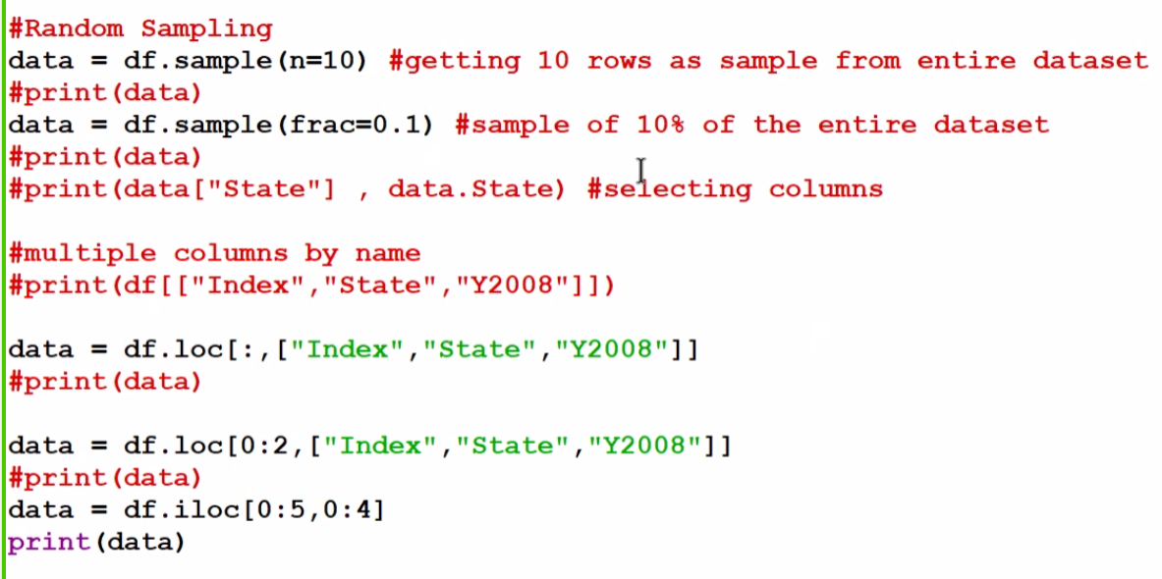

Creating data using

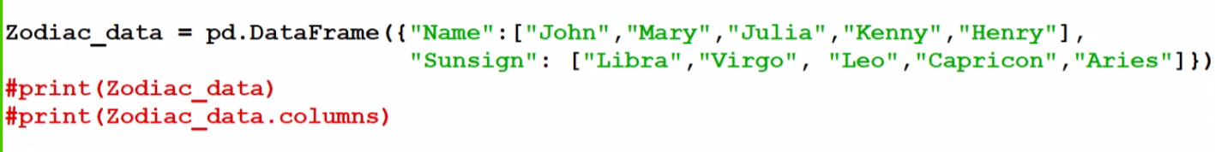

Rename all columns

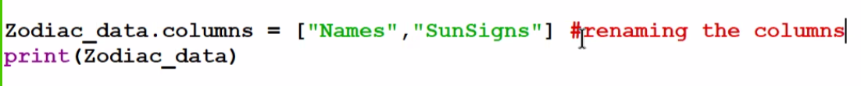

Rename single column = inplace=True is very Impt



Replace word to other word

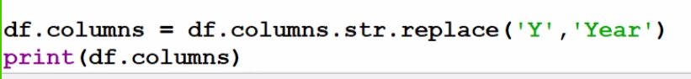

To set the index

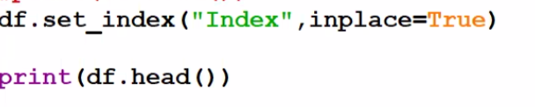

To reset the index

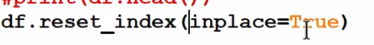

Delete the full column using column name



Delete rows using index value



Axis =0 🡪 rows

Axis =1 🡪 column

Sorting values

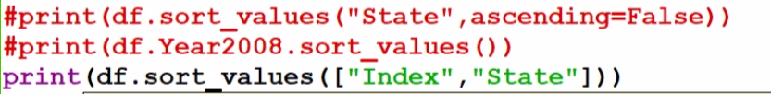

Create new column

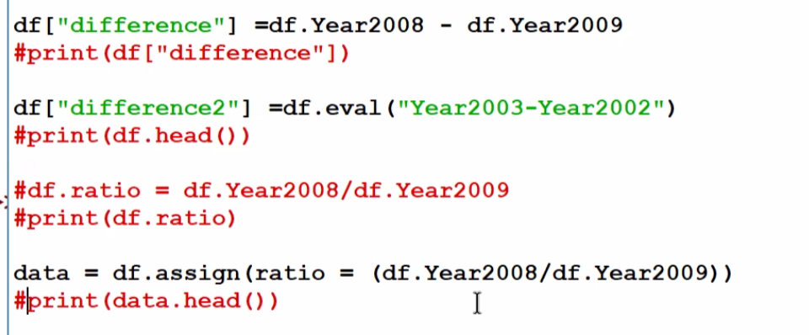

Describe

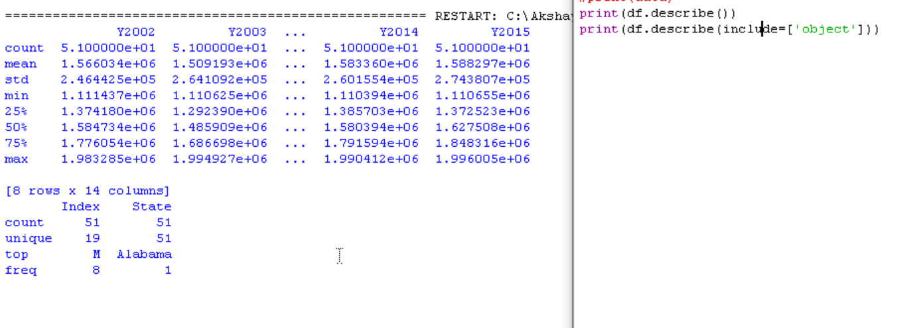

Mean and median

Agg 🡪 aggregation we use when we need min max and mean all value at once

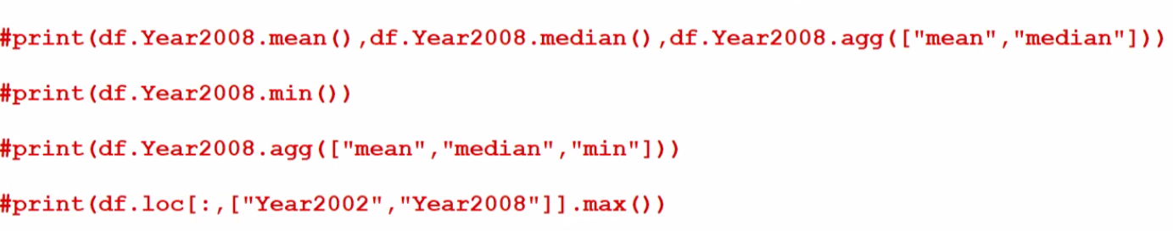

Group by:

Note: correct the below code from the image

Print(df.groupby(“index”)[[“Y2014”,”Y2015”]].mix())

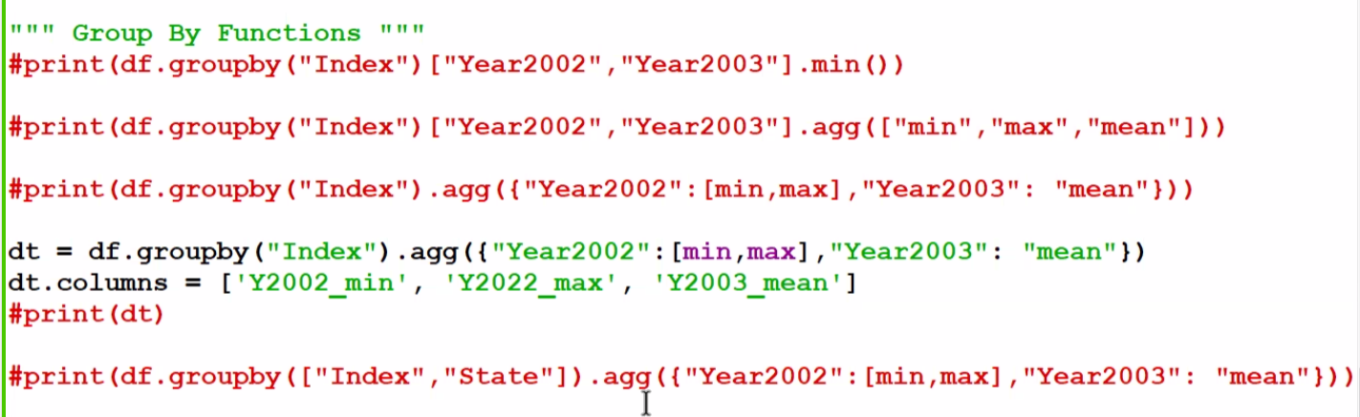

Filterin

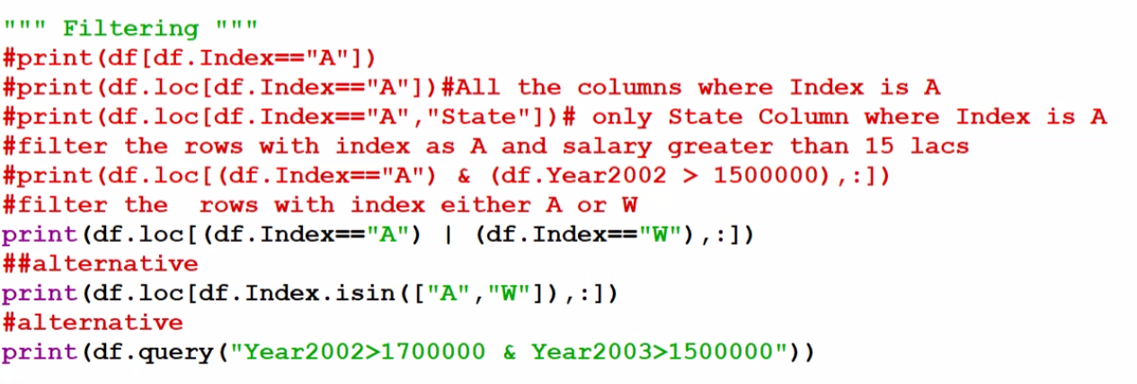

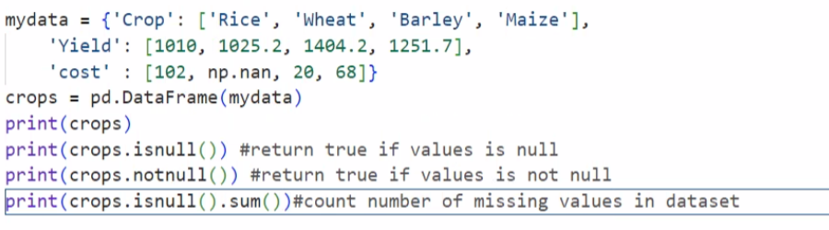

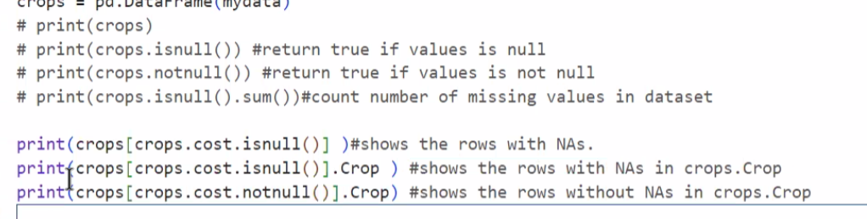

Drop:



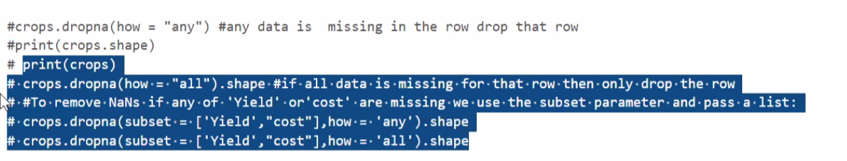

Replace null value to default value

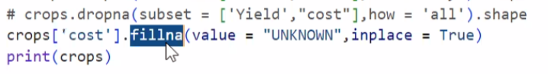

Rmove dublicate:

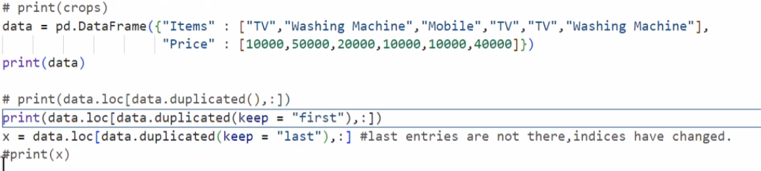

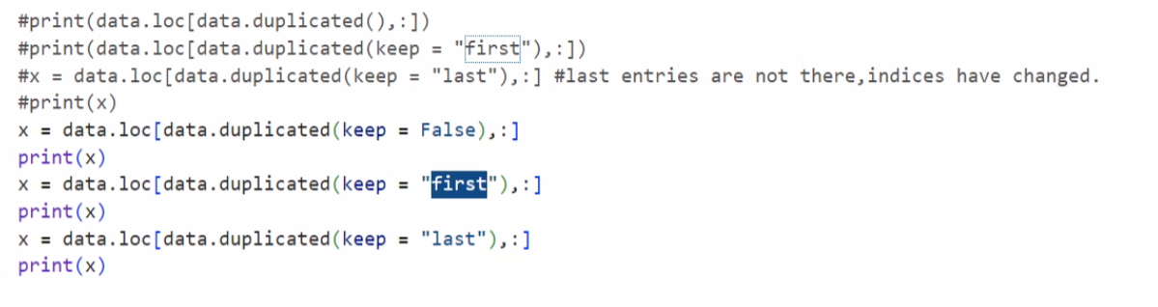

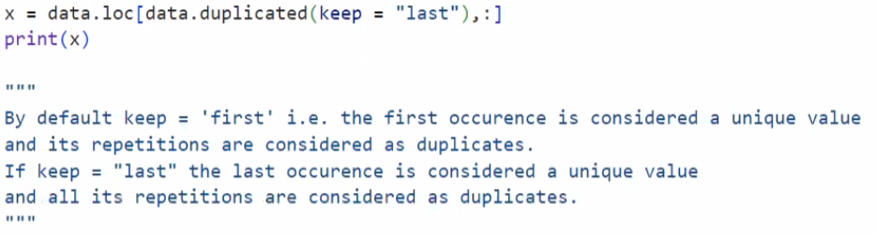

Delete dublicate

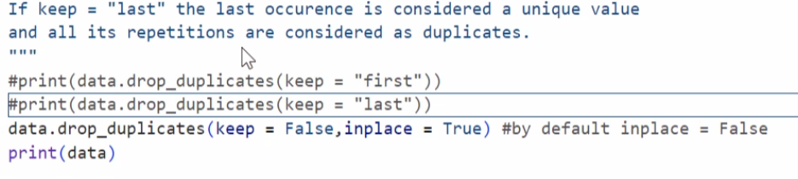

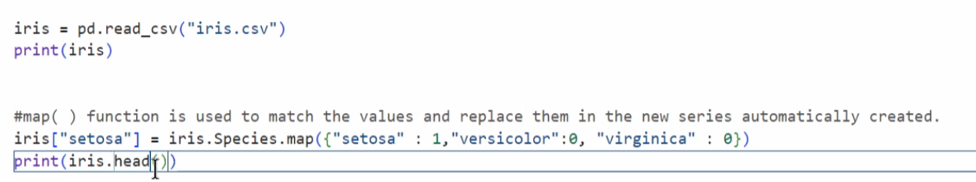

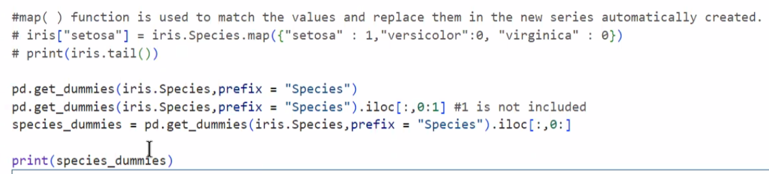

Concatenation

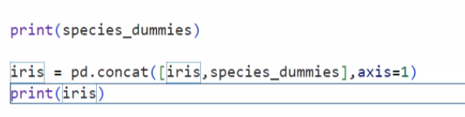

Rank:

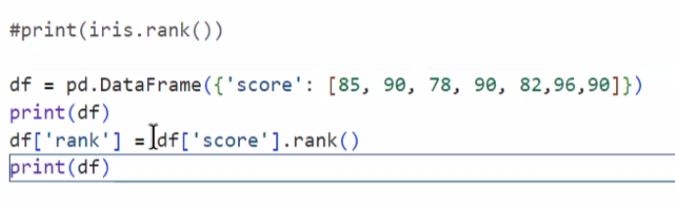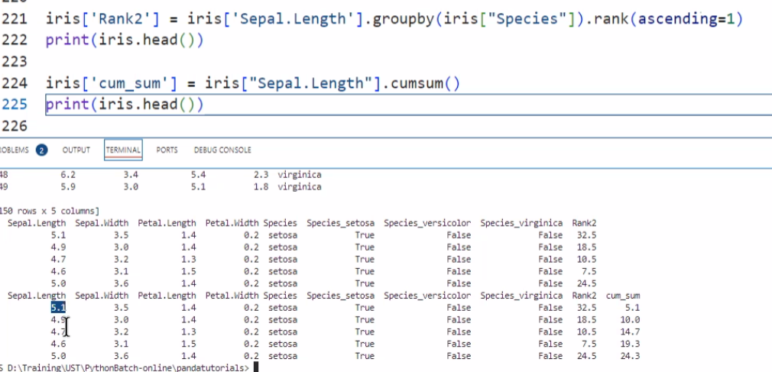

Ecercise 2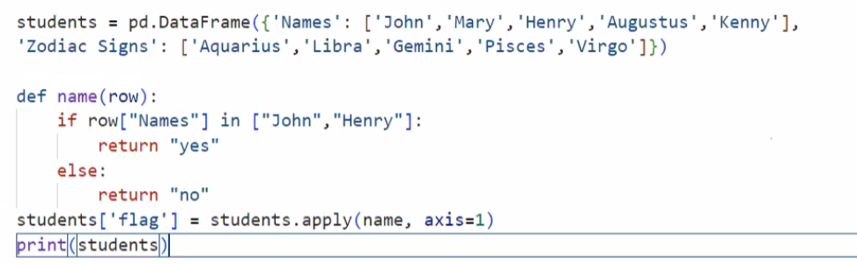

Other way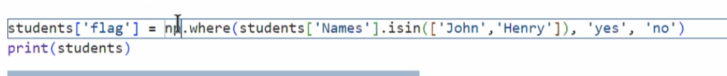

output

